**Kingdom of Saudi Arabia**

**Ministry of Education**

**Shaqra University**

**College of Computing and Information**

**Technology Department**

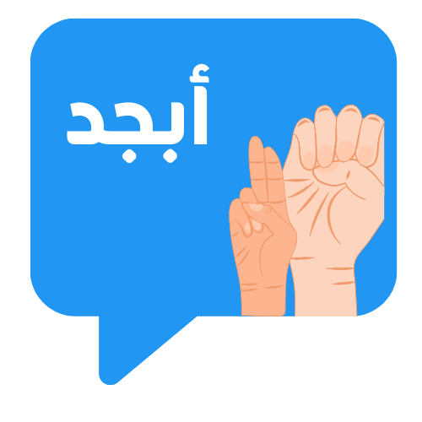

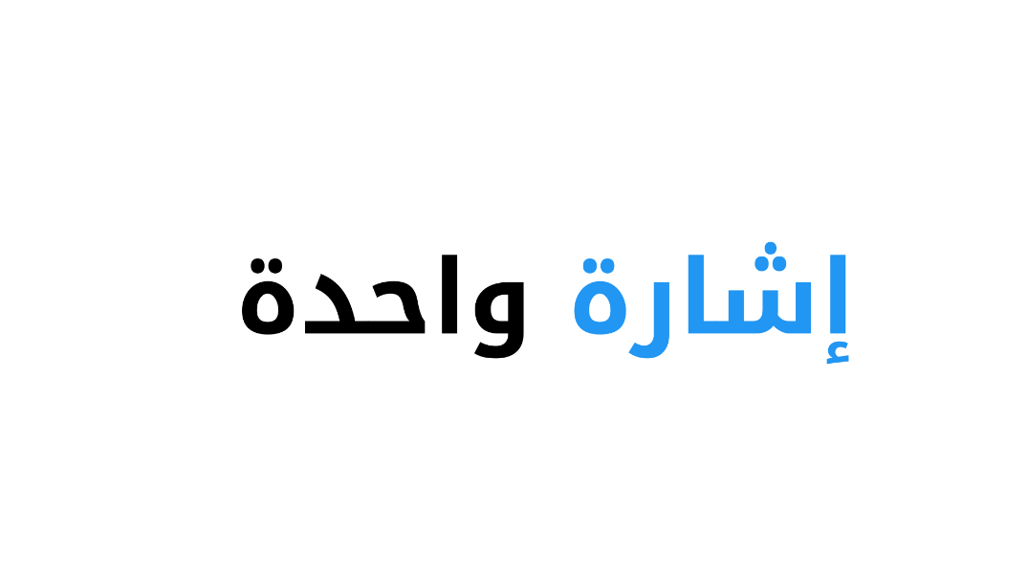

**Graduation project REPORT**

**2023-2024**

**Supervisor:**

Dr. Samia Dardouri

**Students: ID:**

Lina Alfawzan 441500234

Rawabi Albaqami 441500243

Reem Alossaimi 441500240

# Abstract

The Sign Language Translator Android application is meticulously crafted to harness the potential of state-of-the-art technology, revolutionizing communication and fostering mutual understanding between individuals who depend on sign language as their primary means of communication and those who are unfamiliar with sign language. All that through the ingenious integration of artificial intelligence, natural language processing, and computer vision. This groundbreaking application strives to dismantle communication barriers and promote inclusivity. One of the key features of this remarkable application is its provision of real-time translation services, facilitating seamless and instantaneous interpretation of sign language gestures into written language. This extraordinary capability enables individuals, irrespective of their level of language proficiency, to engage in effective communication, thus bridging the divide. Furthermore, the application goes above and beyond by offering the unique ability to translate text or voice inputs into Arabic Sign Language (ArSL). Additionally, the application provides a comprehensive dictionary that allows users to learn and understand the representation of words in ArSL, empowering them to expand their vocabulary and enhance their sign language skills. the Sign Language Translator application is designed with user-friendliness in mind. Its intuitive interface and user-friendly features make it accessible to individuals of all ages and technological backgrounds.

# موجز المشروع باللغة العربية

تم تصميم تطبيق مترجم لغة الإشارة للأندرويد بدقة لتسخير إمكانات التكنولوجيا الحديثة، وإحداث ثورة في التواصل وتعزيز التفاهم المتبادل بين الأفراد الذين يعتمدون على لغة الإشارة كوسيلة أساسية للاتصال وأولئك الذين ليسوا على دراية بلغة الإشارة. كل ذلك من خلال التكامل المبتكر بين الذكاء الاصطناعي ومعالجة اللغة الطبيعية ورؤية الكمبيوتر. يسعى هذا التطبيق الرائد إلى تفكيك حواجز الاتصال وتعزيز الشمولية. إحدى الميزات الرئيسية لهذا التطبيق الرائع هو توفير خدمات الترجمة في الوقت الفعلي، مما يسهل الترجمة الفورية والسلسة لإيماءات لغة الإشارة إلى اللغة المكتوبة. تتيح هذه القدرة الاستثنائية للأفراد، بغض النظر عن مستوى كفاءتهم اللغوية، المشاركة في التواصل الفعال، وبالتالي سد الفجوة. علاوة على ذلك، يذهب التطبيق إلى أبعد من ذلك من خلال تقديم قدرة فريدة على ترجمة المدخلات النصية أو الصوتية إلى لغة الإشارة العربية. بالإضافة إلى ذلك، يوفر التطبيق قاموسًا شاملاً يسمح للمستخدمين بتعلم وفهم تمثيل الكلمات في لغة الإشارة العربية، مما يمكّنهم من توسيع مفرداتهم وتعزيز مهاراتهم في لغة الإشارة. تم تصميم تطبيق مترجم لغة الإشارة مع مراعاة سهولة الاستخدام. واجهته البديهية وميزاته سهلة الاستخدام تجعله في متناول الأفراد من جميع الأعمار والخلفيات التكنولوجية.

Table of Content

Abstract2

موجز المشروع باللغة العربية2

1. Introduction7

1.1 Background 8

1.2 Motivation 11

1.3 Problem Description 12

1.4 Suggested Solution 14

1.5 Digitization and Vision 203015

1. Literature Review 17
2. Requirements21

3.1 Hardware 21

3.2 System & Software 21

3.3 User Level24

3.4 Data and Contents24

1. Project Management Strategies Involved in the Project 26
   1. Project Scope 26

4.2 Role of each project team member 27

4.3 Time Plane of the Project28

4.4 Suggested Business Modal 29

1. Materials and Methods…………………………………………………………………………………………………………………31

5.1 Use Case………………….………………………………………………………………………………………………………………….31

5.2 Sequence Diagram………………………………………………………………………………………………………………………32

5.3 Activity Diagram………………………………………………………………………………………………………………………...36

* 1. Application Functionality…………………………………………………………………………………………………………..37
  2. Design Overview (UI\UX)………………….............................................................................................38

1. Results and Discussion………………………………………………………………………………………………………………….40
2. Conclusions and Future Work……………………………………………………………………………………………………….44

## **Biography………………………………………………………………………………………………………………………………..….45**

# References.………………………………………………………………………………………………………………………………….46

Table of Figures

Figure 1: Fingerspelling alphabet in ArSL8

Figure 2: AI Subsets 9

Figure 3: Natural Language Processing 10

Figure 4: Projected number of people with disabling hearing loss worldwide (in millions).11

Figure 5: The number of people with special needs who responded to the questionnaire (Question1)12

Figure 6: The number of people with special needs who have difficulty communicating (Question2)12

Figure 7: Measuring the number of people without special needs who have difficulty communicating (Question3)13

Figure 8: Percentage of people who know that each language has its own sign language (Question4)13

Figure 9: The number of people who are fluent in Arabic Sign Language (Question5).13

Figure 10: Use case diagram…………………………………………………………………………………………………………………….30

Figure 11: Sequence diagram illustrate the text-to-sign functionality………………………………………………………31

Figure 12: Sequence diagram illustrate the voice-to-sign functionality…………………………………………………….32

Figure 13: Sequence diagram illustrate real-time conversion functionality………………………………………………33

Figure 14: Sequence diagram illustrate the dictionary……………………………………………………………………………..34

Figure 15: Activity diagram………………………………………………………………………………………………………………………35

Figure 16: Real-time translation bridges communication between deaf/mute and non-deaf/mute via mobile camera…………………………………………………………………………………………………………………………………………36

Figure 17: Communication without barriers: Voice and text interaction between hearing/speaking and deaf/mute individuals……………………………………………………………………………………………………………………………..36

Figure 18: Inclusive learning: Arabic Sign Language for all……………………………………………………………………….36

Figure 19: Simplified User Experience: Navigate, Discover, Engage………………………………………………………….37

Figure 20: Stunning Modern User Interface: Enhancing User Interaction…………………………………………………38

Figure 21: P_curve …………………………………………………………………………………………………………………………………..39

Figure 22: PR_curve………………………………………………………………………………………………………………………………...39

Figure 23: F1_curve.…………………………………………………………………………………………………………………………………39

Figure 24: R_curve.…………………………………………………………………………………………………………………………………..39

Figure 25: Confusion matrix …………………………………………………………………………………………………………………….39

Figure 26: Interface of real time sign detection…………………………………………………………………………...............41

Figure 27: Interface of sign detection of image from gallery…………………………………………………………………....41

Figure 28: Interface of text/voice into sign language translation………………………………………………………………42

Figure 29: Interface of the result of translation……………………………………………………………………………………....42

Figure 30: Interface of dictionary (alphabet section)………………………………………………………………………………..43

Figure 31: Interface of dictionary after flipping the card………………………………………………………………………....43

**Table of Tables**

Table 1. Summary of Authors' Projects in Sign Language Recognition (SLR) Systems. 20

Table 2. Comparing our application with existing applications in the Saudi market. 21

Table 3. Relevant Datasets Used in SLR systems. 24

Table 4. Timeline of the Project (term1) 28

Table 5. Time line of the project (term2) 29

Table 6. Use case. 31

Table of Abbreviations

|  |  |
| --- | --- |
| Abbreviation | Meaning |
| 12GB RAM | Random Access Memory size (in gigabytes). |
| 12MP telephoto | 12-megapixel telephoto camera. |
| 12MP wide | 12-megapixel wide-angle camera. |
| 16MP ultrawide | 16-megapixel ultrawide-angle camera. |
| 256GB internal storage | Internal storage capacity (in gigabytes). |
| 6.8-inch | Measurement of the screen size (in inches). |
| ASL | American Sign Language. |
| APK | Android Package Kit. |
| Android version 12 | Operating system version. |
| ArSL | Arabic Sign Language. |
| AI | Artificial Intelligence. |
| ANN | Artificial Neural Network. |
| BSL | British Sign Language. |
| CPU | Central Processing Unit. |
| CNNs | Convolutional Neural Networks. |
| DNNs | Deep Neural Networks. |
| Dynamic AMOLED | Display technology used (Active-Matrix Organic Light Emitting Diode). |
| Exynos 9825 | Samsung Exynos 9825 processor. |
| Galaxy Note 10+ | Model name of the Samsung smartphone. |
| GHz | Gigahertz (unit of frequency, indicating the speed of the CPU). |
| GB | Gigabytes (unit of digital storage capacity). |
| GUI | Graphical User Interface. |
| GIF | Graphics Interchange Format. |
| GPU | Graphics Processing Units. |
| HP | Hewlett-Packard (brand name). |
| HMM | Hidden Markov Model. |
| IDE | Integrated Development Environment. |
| IntelliJ IDEA | Integrated Development Environment for Java. |
| Intel | Integrated Electronics (company name). |
| i7 | Intel Core i7 (specific series of Intel processors). |
| LMC | Leap Motion Controller. |
| ML | Machine Learning. |
| MBaaS | Mobile Backend-as-a-Service. |
| 8550U | Model number of the Intel Core i7 processor. |
| MSHMM | Multi Stream HMM. |
| MLP | Multilayer Perceptron. |
| NBC | Naïve Bayes Classifier. |
| NLP | Natural Language Processing. |
| NN | Neural Network. |
| Core | Processor core (a processing unit within the CPU). |
| Quad-camera setup | Four-camera arrangement on the device. |
| RAM | Random Access Memory. |
| RNNs | Recurrent Neural Networks. |
| RGB | Red, Green, Blue. |
| Samsung | South Korean multinational conglomerate company (brand name). |
| SOFM | Self-Organizing Feature Map. |
| SOM | Self-Organizing Map. |
| SLR | Sign Language Recognition. |
| SRN | Simple Recurrent Network. |
| Snapdragon 855 | Qualcomm Snapdragon 855 processor. |
| SDK | Software Development Kit. |
| SVM | Support Vector Machine. |
| TPU | Tensor Processing Unit. |
| 3D | three-dimensional. |
| TM | Trademark. |
| UML | Unified Modeling Language. |
| UX | User Experience. |
| UI | User Interface. |

# Introduction

Arabic Sign Language (ArSL) is a complete, natural language that has the same linguistic properties as spoken languages, with grammar that differs from Arabic. ArSL is expressed by movements of the hands and face. It is the primary language of many middle east who are deaf and hard of hearing, and is used by many hearing people as well.

There is no universal sign language, different sign languages are used in different countries or regions. For example, British Sign Language (BSL) is a different language from, American Sign Language (ASL), and Americans who know ASL may not understand BSL. Some countries adopt features of ASL in their sign languages.

No person or committee invented ArSL. It contains all the fundamental features of language, with its own rules for pronunciation, word formation, and word order. While every language has ways of signaling different functions, such as asking a question rather than making a statement, languages differ in how this is done. For example, English speakers may ask a question by raising the pitch of their voices and by adjusting word order; ArSL users ask a question by raising their eyebrows, widening their eyes, and tilting their bodies forward. Just as with other languages, specific ways of expressing ideas in ArSL vary as much as ArSL users themselves. In addition to individual differences in expression, ASL has regional accents and dialects; just as certain Arabic words are spoken differently in different parts of the country, ArSL has regional variations in the rhythm of signing, pronunciation, slang, and signs used. Other sociological factors, including age and gender, can affect ArSL usage and contribute to its variety, just as with spoken languages.

Fingerspelling is part of ArSL and is used to spell out Arabic words. In the finger spelled alphabet, each letter corresponds to a distinct handshape. Fingerspelling is often used for proper names or to indicate the Arabic word for something. Parents are often the source of a child’s early acquisition of language, but for children who are deaf, additional people may be models for language acquisition. A deaf child born to parents who are deaf and who already use ArSL will begin to acquire ArSL as naturally as a hearing child picks up spoken language from hearing parents. However, for a deaf child with hearing parents who have no prior experience with ArSL, language may be acquired differently. In fact, 9 out of 10 children who are born deaf are born to parents who hear [1].

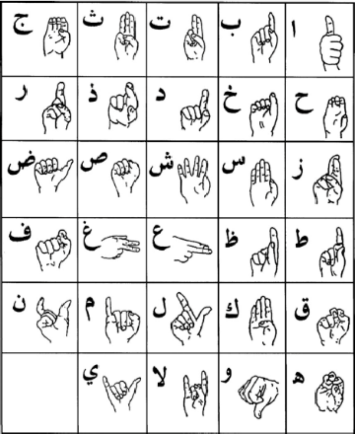

Figure 1: Fingerspelling alphabet in ArSL [2]

Some hearing parents choose to introduce sign language to their deaf children, hearing parents who choose to have their child learn sign language often learn it along with their child. Children who are deaf and have hearing parents often learn sign language through deaf peers and become fluent.

In order to bridge the Gap between these children and adults the use of Computer vision and Feature Extraction techniques are important as there is no necessity of a 3rd Party to help with the Translation of the ArSL Language.

Therefore, to build a system that can recognize sign language will help the deaf and hard-of hearing better communicate using modern-day technologies. In this report, we will go through computer vision and machine learning to see how it performs on classifying Sign Language.

1.1 Background

An automation system that can translate sign language into spoken language can aid the hearing impaired in interacting with normal people. Plenty of research has been carried out to develop a sign language recognition structure using wearable devices such as a hand glove equipped with a flex sensor and an accelerometer sensor [3]. More advanced research for recognition methodology is proposed, which utilizes a webcam and a Kinect in place of wearable devices [4]. But most of the approaches mentioned above [3, 4] have been implemented using computers and laptops, which are nowadays impractical to carry along everywhere. The panacea to all these problems is the smartphone, which will act as an effective way to bridge the existing gap between the deaf-mute and other people. In this paper, the development of a system to recognize and interpret Arabic Sign Language (ArSL) based on Android devices has been presented.

Deep learning and computer vision play a crucial role in sign language recognition, interpretation, and translation. They enable the development of advanced systems that can understand and process sign language gestures, facilitating communication between individuals who use sign language and those who do not.

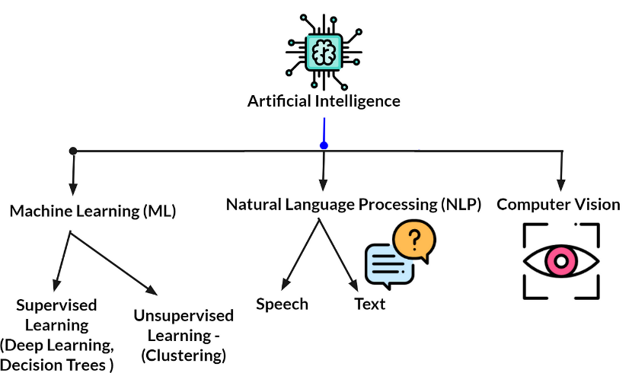

Figure 2: AI Subsets [5]

Here are some key roles of computer vision and deep learning in sign language:

* **Gesture Recognition**: Computer vision techniques, combined with deep learning algorithms, can be used to recognize and interpret sign language gestures. By analyzing video or image sequences of hand movements and body postures, these systems can identify specific signs and gestures, allowing for real-time interpretation and translation.
* **Hand Tracking:** Computer vision algorithms can track and locate the position and movement of hands in sign language. This information is essential for understanding and interpreting the meaning of various signs and gestures. Hand tracking algorithms can accurately identify hand shapes, finger movements, and hand trajectories, providing valuable input for sign language recognition systems.
* **Sign Language Translation:** Deep learning models, such as convolutional neural networks (CNNs) and recurrent neural networks (RNNs), can be trained to recognize and translate sign language into spoken or written language. These models learn from large datasets of sign language videos or images, capturing the visual patterns and correlations between signs and their corresponding meanings. Sign language translation systems powered by deep learning can bridge the communication gap between sign language users and non-signers.
* **Improving Accessibility:** Computer vision and deep learning techniques can be integrated into assistive technologies and devices to enhance accessibility for individuals with hearing impairments. For example, sign language recognition systems can be integrated into smart cameras or wearable devices to provide real-time interpretation and translation.

Natural language processing (NLP) refers to the branch of computer science—and more specifically, the branch of artificial intelligence or AI—concerned with giving computers the ability to understand text and spoken words in much the same way human beings can.

NLP combines computational linguistics—rule-based modeling of human language—with statistical, machine learning, and deep learning models. Together, these technologies enable computers to process human language in the form of text or voice data and to ‘understand’ its full meaning, complete with the speaker or writer’s intent and sentiment. NLP drives computer programs that translate text from one language to another, respond to spoken commands, and summarize large volumes of text rapidly—even in real time [6].

Figure 3: Natural Language Processing [50]

1.2 Motivation

The motivation for developing an Arabic sign language application stem from the pressing need to address the communication barriers faced by individuals with hearing impairments in Arabic-speaking countries. The limited availability of comprehensive resources and tools for learning and communicating in Arabic sign language has hindered the social integration and participation of the deaf community.

By leveraging the power of modern smartphone technologies, our project aims to provide an accessible and user-friendly platform that empowers individuals to learn and communicate effectively in Arabic sign language. This application strives to bridge the gap in resources, promote inclusivity, and foster understanding between the deaf community and those who interact with them. By facilitating sign language learning and communication, we aspire to enhance the quality of life for individuals with hearing impairments and contribute to a more inclusive society.

Figure 4: Projected number of people with disabling hearing loss worldwide (in millions) [7]

.

1.3 Problem Description

The problem at hand revolves around the limited availability of comprehensive resources and tools for learning and communicating in Arabic sign language. The deaf community in Arabic-speaking countries faces significant challenges in accessing quality educational materials and platforms that cater specifically to their needs. This lack of resources hampers their ability to learn and communicate effectively in Arabic sign language, hindering their social integration and participation in various aspects of society.Also, the absence of a dedicated and interactive platform for acquiring proficiency in Arabic sign language further exacerbates the problem.

All of this was inferred through a questionnaire that was published by us in various regions of Saudi Arabia, with 80 responses from both the healthy community and those suffering from hearing and deaf problems.

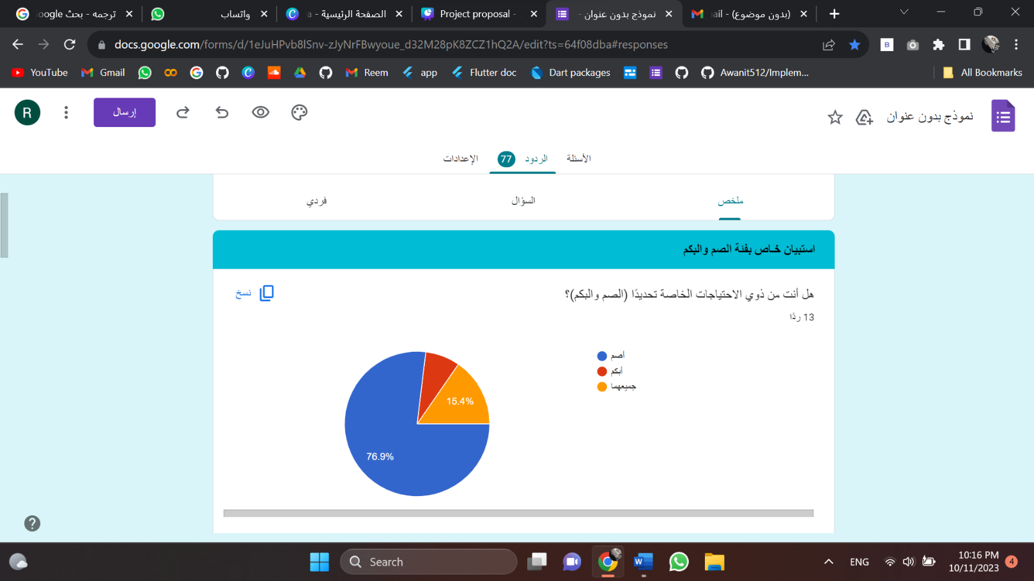For people with special needs:

Figure 5: The number of people with special needs who responded to the questionnaire (Question1)

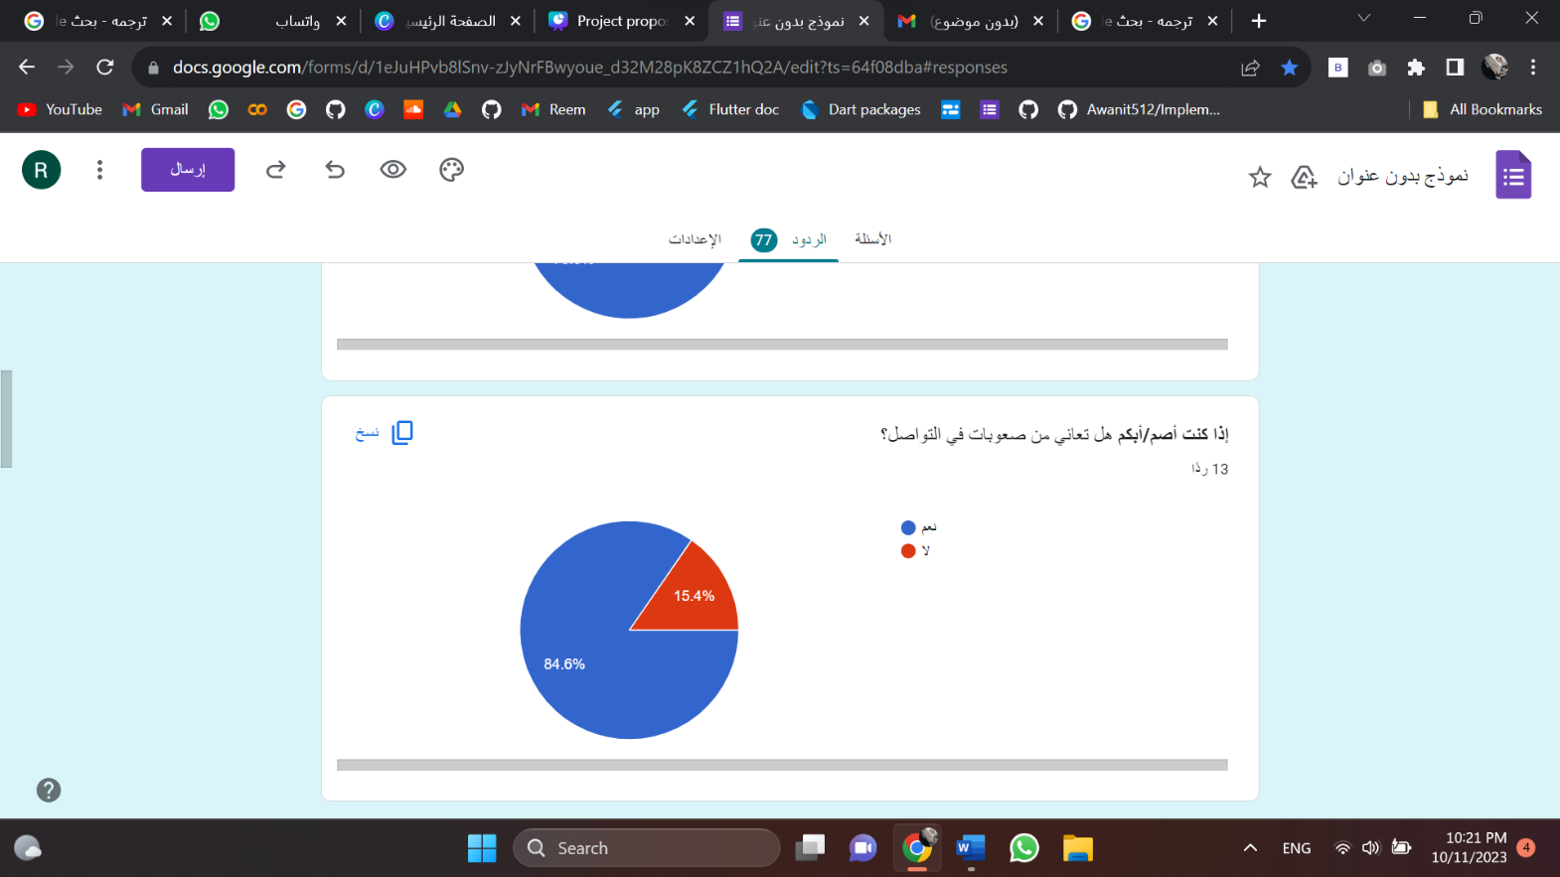

Figure 6: The number of people with special needs who have difficulty communicating (Question2)

For Normal people:

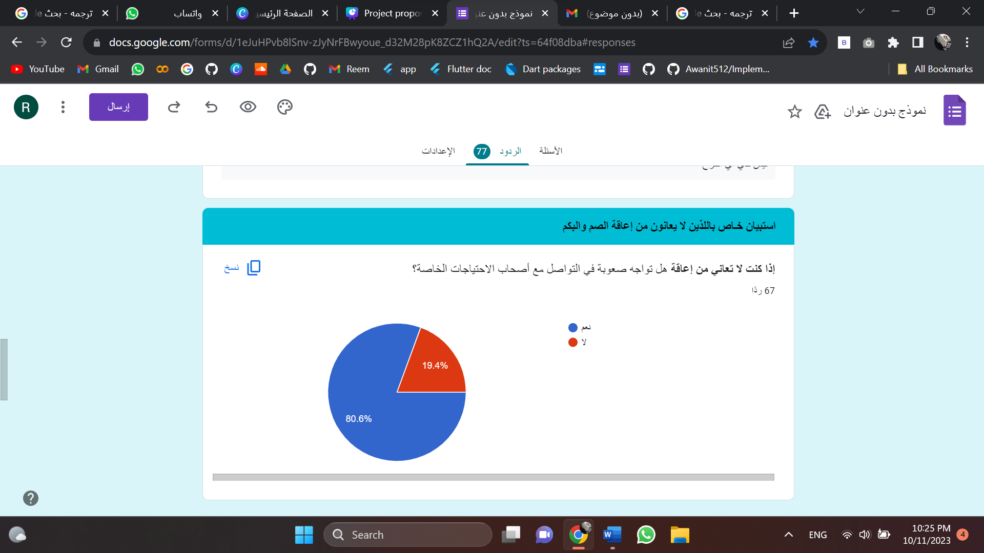

Figure 7: Measuring the number of people without special needs who have difficulty communicating (Question3)

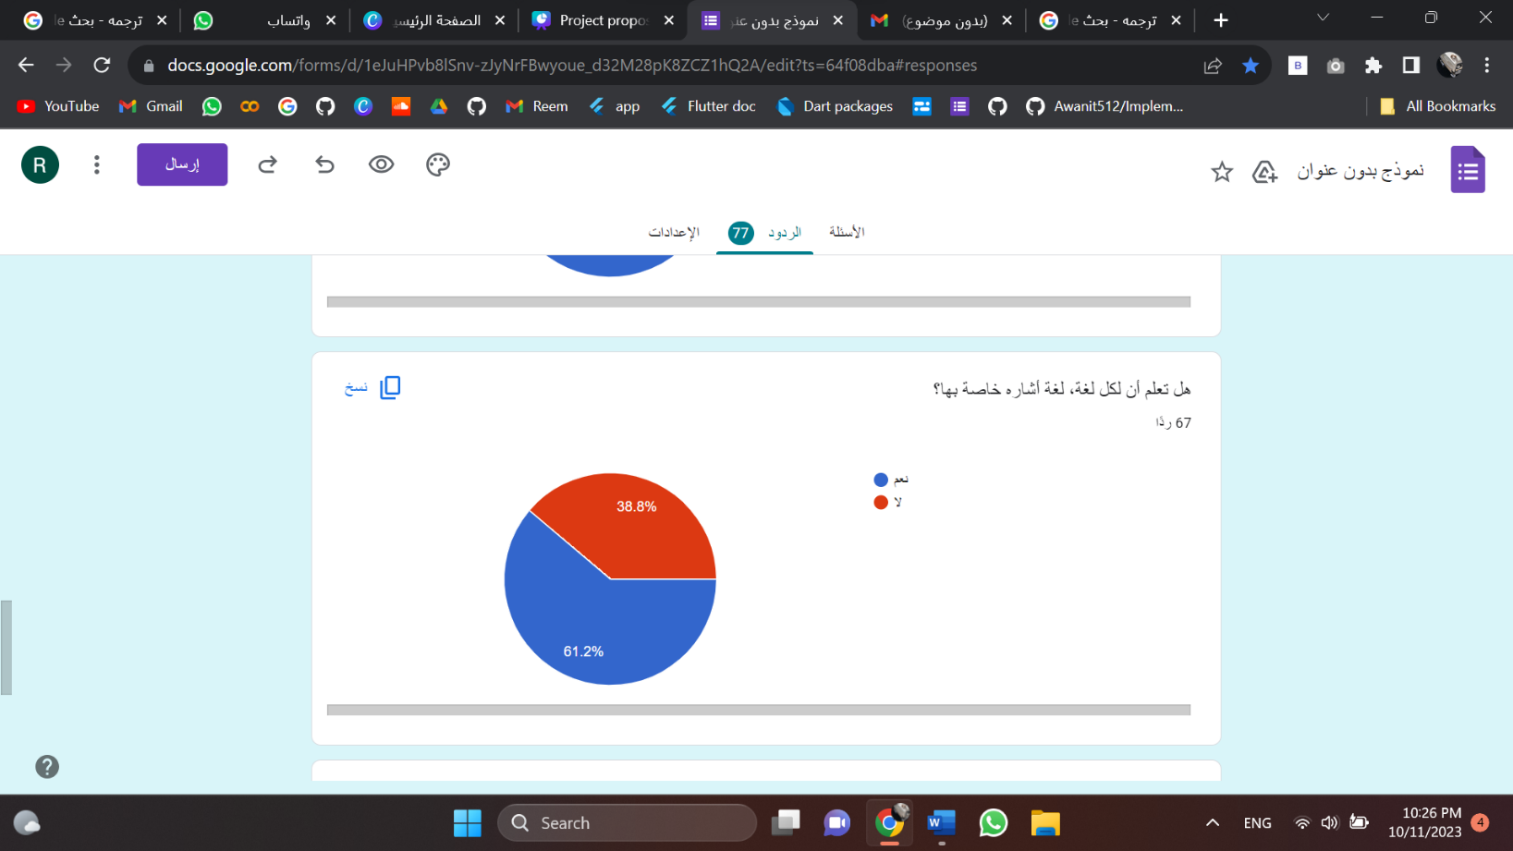

Figure 8: Percentage of people who know that each language has its own sign language (Question4)

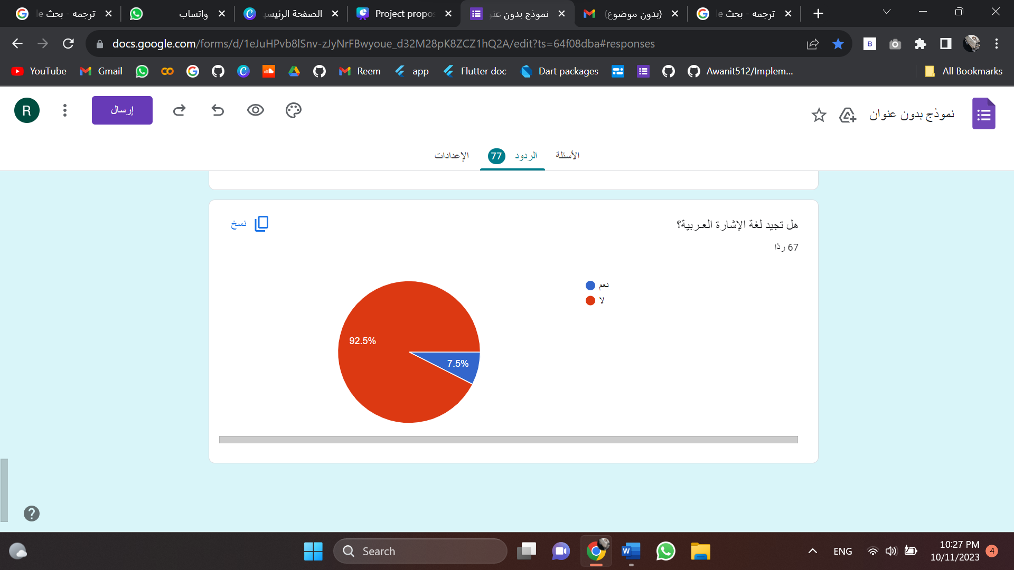

Figure 9: The number of people who are fluent in Arabic Sign Language (Question5)

Therefore, there is an urgent need to develop a solution that leverages the capabilities of modern smartphone technologies to provide an accessible and comprehensive learning environment for Arabic sign language learners, empowering them to communicate effectively and fostering inclusivity in the community.

1.4 Suggested Solution

Sign languages are the primary means of communication for individuals with hearing impairments. These languages utilize a combination of hand gestures, facial expressions, and body movements to convey meaning. However, the availability of resources and tools for sign language learning and communication is limited, particularly in the context of Arabic sign language.

Arabic sign language is a distinct visual language used by the deaf community in Arabic-speaking countries. It plays a crucial role in facilitating communication and social integration for individuals with hearing disabilities. Unfortunately, the lack of comprehensive learning tools and accessible resources poses significant challenges for both the deaf community and those seeking to learn and communicate in Arabic sign language.

To address this issue, our project aims to develop an Android application dedicated to Arabic sign language learning and communication. This application will leverage the capabilities of modern smartphone technologies to provide an interactive and user-friendly platform for individuals to acquire proficiency in Arabic sign language.

**1.4.1 Objectives**

The main objective of our project is to create an immersive and comprehensive experience for learning Arabic sign language. It includes the following:

* **Sign Language Learning:** The application will offer a comprehensive curriculum that covers the fundamentals of Arabic sign language, including vocabulary, grammar, and sentence structure. Through interactive lessons, users will be able to learn and practice different signs, gestures, and expressions.
* **Translation and Communication:** The application will incorporate a translation feature that allows users to convert Arabic text or speech into corresponding sign language gestures. This functionality will enhance communication between individuals who are proficient in Arabic but have limited or no knowledge of sign language and those who rely on sign language to communicate.
* **Dictionary and Reference:** A comprehensive sign language dictionary will be integrated into the application, providing users with a searchable database of Arabic sign language vocabulary. This resource will serve as a reference tool for both learners and experienced sign language users, facilitating the expansion of their sign language proficiency.
* **Accessibility and Customization:** The application will prioritize accessibility, considering the diverse needs and preferences of its users. It will include adjustable font sizes, color contrast options, and support for different input methods (e.g., touch, voice commands). Additionally, the application will offer customization features, allowing users to personalize their learning experience based on their skill level and learning pace.

By developing an Arabic sign language Android application, we aim to bridge the gap in resources and promote inclusivity for individuals with hearing impairments. This project endeavors to empower both the deaf community and those seeking to communicate effectively with them, fostering understanding, equality, and social integration.

1.5 Digitization and Vision 2030

The benefits of Arabic sign language Android application align with the Vision 2030 of Saudi Arabia and contribute to the concept of digitization in the country in the following ways:

* **Inclusivity and Empowerment:** The project promotes inclusivity by providing individuals with hearing impairments in Saudi Arabia with a platform to learn and communicate effectively in Arabic sign language. This aligns with the Vision 2030 goal of creating an inclusive society that provides equal opportunities for all citizens.
* **Enhanced Communication and Social Integration:** By bridging the communication gap between sign language users and non-signers, the application promotes effective communication and social integration. This aligns with the Vision 2030 objective of fostering a vibrant society that embraces diversity and encourages meaningful interactions among its members.
* **Access to Quality Education:** The application offers a comprehensive curriculum and learning resources for Arabic sign language, empowering individuals to acquire proficiency in the language. This aligns with the Vision 2030 goal of providing high-quality education and lifelong learning opportunities to all Saudi citizens.

* **Technological Advancement:** The project leverages modern smartphone technologies, such as computer vision and deep learning, to facilitate sign language learning and communication. By incorporating these cutting-edge technologies, the project embraces the concept of digitization and contributes to the technological advancement of Saudi Arabia in line with the Vision 2030 plan.

* **Digital Transformation:** The Arabic sign language Android application represents a digital solution that enhances accessibility and communication for individuals with hearing impairments. By embracing digitization and leveraging technology to address societal challenges, the project exemplifies the digital transformation objectives outlined in the Vision 2030 plan.

By aligning with the Vision 2030 goals, our project not only addresses the specific needs of the deaf community in Saudi Arabia but also contributes to the broader vision of transforming the country into a vibrant and inclusive society while embracing the benefits of digital technologies, and that is the core of Vision 2030.

# Literature Review

Sign Language Recognition (SLR) is a very vast topic for research where a lot of work has been done but still various things need to be addressed. The machine learning techniques allow the electronic systems to take decisions based on experience i.e., data. The classification algorithms need two datasets – training dataset and testing dataset. The training set provides experiences to the classifier and the model is tested using the testing set [8]. Many authors have developed efficient data acquisition and classification methods [9, 10]. Based on data acquisition method, previous work can be categorized into two approaches: the direct measurement methods and the vision-based approaches [9]. The direct measurement methods are based on motion data gloves, motion capturing systems, or sensors. The motion data extracted can supply accurate tracking of fingers, hands, and other body parts which leads to robust SLR methodologies development. The vision-based SLR approaches rely on the extraction of discriminative spatial and temporal from RGB images. Most of the vision-based methods initially try to track and extract the hand regions before their classification to gestures [9]. Hand detection is achieved by semantic segmentation and skin color detection as the skin color is usually distinguishable easily [11, 12]. Though, because the other body parts like face and arms can be mistakenly recognized as hands, so, the recent hand detection methods also use the face detection and subtraction, and background subtraction to recognize only the moving parts in a scene [13, 14]. To attain accurate and robust hands tracking, particularly in cases of obstructions, authors employed filtering techniques, for example, Kalman and particle filters [13, 15].

For data acquisition by either the direct measurement or the vision-based approaches, different devices need to be used. The primary device employed as input process in SLR system is camera [16]. There are other devices available that are used for input such as Microsoft Kinect which provides color video stream and depth video stream all together. The depth data helps in background segmentation. Apart from the devices, other methods used for acquiring data are accelerometer and sensory gloves. Another system that is used for data acquisition is Leap Motion Controller (LMC) [17, 18] – it is a touchless controller developed by technology company “Leap Motion” now called “Ultraleap” based in San Francisco. Approximately, it can operate around 200 frames per second and can detect and track the hands, fingers, and objects that look alike fingers. Most of the researchers collect their training dataset by recording it from their signer as finding a sign language dataset is a problem [19].

Different processing methods have been used for creating an SLR system [20, 21, 22]. Hidden Markov Model (HMM) has been widely used in SLR [15]. The various HMM that have been used are Multi Stream HMM (MSHMM) which is based on the two-standard single-stream HMMs, Light-HMM, and Tied-Mixture DensityHMM [19]. The other processing models that have been used are neural network [23, 24, 25, 26, 27], ANN [28], Naïve Bayes Classifier (NBC), and Multilayer Perceptron (MLP) [17], unsupervised neural network Self-Organizing Map (SOM) [29], Self-Organizing Feature Map (SOFM), Simple Recurrent Network (SRN) [30], Support Vector Machine (SVM) [31], 3D convolutional residual network [32]. Researchers have also used self-designed methods like the wavelet-based method [33] and Eigen Value Euclidean Distance [25].

The use of different processing methods or application systems has given different accuracy results. The Light-HMM gave 83.6% accuracy result, the MSHMM gave 86.7% accuracy result, SVM gave 97.5% accuracy result, Eigen Value gave 97% accuracy result, Wavelet Family gave 100% accuracy result [19, 26, 34, 35]. Though different models have given high accuracy results, but the accuracy does not depend only on the processing model used, it depends upon various factors such as size of the dataset, clarity of images of the dataset depending upon data acquisition methods, devices used, etc.

There are two types of SLR systems – isolated SLR and continuous SLR. In isolated SLR, the system is trained to recognize a single gesture. Each image is labelled to represent an alphabet, a digit, or some special gesture. Continuous SLR is different from isolated gesture classification. In continuous SLR, the system is able to recognize and translate whole sentences instead of a single gesture [36, 37].

Table 1. Summary of Authors' Projects in Sign Language Recognition (SLR) Systems.

|  |  |  |
| --- | --- | --- |
| Reference | Processing Methods | Accuracy Results |
| [15] | Hidden Markov Model (HMM). | - |
| [28] | Artificial Neural Network (ANN). | - |
| [23, 24, 38, 26, 27] | Neural Network (NN). | - |
| [29] | Unsupervised neural network Self-Organizing Map (SOM) | - |
| [30] | Self-Organizing Feature Map (SOFM), Simple Recurrent Network (SRN). | - |
| [31] | Support Vector Machine (SVM). | Gave 97.5% accuracy result. |
| [32] | 3D convolutional residual network. | - |
| [33] | Wavelet-based method. | Wavelet Family gave 100% accuracy result. |
| [25] | Eigen Value Euclidean Distance. | Gave 97% accuracy result. |
| [17] | Naïve Bayes Classifier (NBC), Multilayer Perceptron (MLP). | - |
| [19] | Hidden Markov Model (HMM), Multi Stream HMM (MSHMM), Light-HMM, Tied-Mixture Density HMM. | The Light-HMM gave 83.6% accuracy result, the MSHMM gave 86.7% accuracy result. |

Even with all the research that has been done in SLR, many inadequacies need to be dealt with by further research. Some of the issues and challenges that need to be worked on are as follows [8, 19, 36, 39].

* Data acquisition by sensors has some issues e.g., noise, bad human manipulation, bad ground connection, etc.
* Vision-based methodologies introduce inaccuracies due to overlapping of hand and background.
* Large datasets are not available.

As for the previous applications available in the Saudi market, there are two applications, “Turjeman” [40] and “Ishara” [41]. In the table below, we compare the basic features of the applications and what our application offers as an addition to them.

|  |  |  |  |
| --- | --- | --- | --- |
|  | Ishara | Table 2. Comparing our application with existing applications in the Saudi market.  *Turjeman* | Our application |
| Convert audio to sign | No | Yes | Yes |
| Convert text to sign | Yes | Yes | Yes |
| Convert Sign to text (Real-time) | Yes | No | Yes |
| Learn sign language by dictionary | No | Yes | Yes |

# Requirements

3.1 Hardware

* + 1. **HP Pavilion Laptop**

A laptop HP with processor Intel(R) Core (TM) i7-8550U CPU @ 1.80GHz 1.99 GHz and RAM of 8GB.

* + 1. **Android note 10+**

The Samsung Galaxy Note 10+ features a 6.8-inch Dynamic AMOLED display, Snapdragon 855 (or Exynos 9825) processor, 12GB RAM, and 256GB internal storage, Android version 12. It has a quad-camera setup with a 12MP wide, 12MP telephoto, and 16MP ultrawide.

* 1. System & Software
     1. Figma

Figma is a popular cloud-based design and prototyping tool used for UI/UX design and collaboration. It allows multiple users to work on a design project simultaneously in real-time.

* + 1. PyTorch

PyTorch is a machine learning library based on the Torch library, used for applications such as computer vision and natural language processing, originally developed by Meta AI and now part of the Linux Foundation umbrella. It is recognized as one of the two most popular machine learning libraries alongside TensorFlow, offering free and open-source software released under the modified BSD license. Although the Python interface is more polished and the primary focus of development, PyTorch also has a C++ interface.

A number of pieces of deep learning software are built on top of PyTorch, including Tesla Autopilot, Uber's Pyro, Hugging Face's Transformers, PyTorch Lightning, and Catalyst [42].

* + 1. Flutter

Open-source UI software development kit (SDK) created by Google. It allows developers to build cross-platform applications for mobile, web, and desktop using a single codebase. Flutter provides a fast and efficient development process, enabling developers to create high-performance and visually appealing applications. It offers a rich set of customizable UI components and animations, with access to native device features through platform-specific plugins. Flutter uses the Dart programming language and has a growing ecosystem of packages and plugins. The framework has a large and active community of developers, providing extensive support and resources for developers. Overall, Flutter is a versatile framework for building cross-platform applications with a focus on performance, productivity, and beautiful user interfaces [44].

That being said, Firebase is also used for web development and can be a great choice for building web applications, particularly those that require real-time data updates or push notifications. Firebase provides a range of web-focused features, such as hosting, cloud functions, and analytics, which make it a powerful option for web development as well. Ultimately, the choice to use Firebase for mobile or web development depends on the specific needs of the project and the developer's preferences and expertise.

* + 1. Android Studio

Is the official integrated development environment (IDE) for Android application development. It is based on IntelliJ IDEA, a Java integrated development environment for software, and incorporates its code editing and developer tools. To support application development within the Android operating system, Android Studio uses a Gradle-based build system, Android Emulator, code templates and GitHub integration. Every project in Android Studio has one or more modalities with source code and resource files. These modalities include Android application modules, Library modules and Google Application Engine modules. Android Studio uses an Apply Changes feature to push code and resource changes to a running application. A code editor assists the developer with writing code and offering code completion, refraction and analysis. Applications built in Android Studio are then compiled into the APK format for submission to the Google Play Store [45].

3.3 User Level

* Real time translating ArSL into text.
* Translating text into ArSL.
* Translating voice into ArSL.
* Learning words representation in ArSL.

3.4 Data and Contents

Dataset is a collection of information or data that can be worked on by machine learning to help create a predicting model.

Table 3. Relevant Datasets Used in SLR systems.

|  |  |  |
| --- | --- | --- |
| Datasets | Description | Accuracy |
| RGB Arabic Alphabet Sign Language (AASL) dataset  [46]. | Consists of 7543 images for the 32 Arabic sign language sign and alphabets collected from different participants in different age groups. | 99.5% |
| Detection of Arabic sign  Language [47]. | Arabic alphabet using 9240  images. Focused on the  classification for 14  alphabetic letters that  represent the first Quran  surahs in the Quranic sign  language (QSL). | 99.5% |
| RGB Arabic Alphabets Sign  Language Dataset [48]. | RGB Arabic Alphabet Sign  Language (AASL) dataset  comprises 7,857 raw and fully labelled RGB images of the Arabic sign language alphabets, collected from more than 200 participants. | 95.5% |

After considering various options, we have selected a comprehensive and highly accurate dataset for our sign language recognition (SLR) system. Which is *RGB Arabic Alphabet Sign Language (AASL) dataset* [46]*.* This dataset stands out due to its extensive coverage and robust performance in accurately capturing sign language gestures. By utilizing this dataset, our SLR system can benefit from a rich and diverse collection of sign language samples, enabling improved accuracy and reliability in recognizing and interpreting sign language gestures.

Also, we will use a dataset comprising animated images called (Tawasol) [49], work as outputs for two specific sections: text into image and audio into image. By utilizing these datasets, our system can generate visually engaging and informative content by transforming text and audio inputs into expressive and visually appealing images.

1. Project Management Strategies Involved in the Project

4.1 Project Scope

The scope of our application includes individuals who are interested in learning and communicating in Arabic sign language. The target user group comprises:

* **Deaf and Hard-of-Hearing Individuals**: The application will cater to individuals with hearing impairments who rely on sign language as their primary mode of communication. It will provide them with a platform to learn Arabic sign language, improve their proficiency, and enhance their communication skills.
* **Sign Language Interpreters:** The application can also be beneficial for sign language interpreters who work with the deaf community. It can serve as a resource for them to expand their knowledge, learn new signs, and improve their interpretation abilities.
* **Educators and Teachers:** Teachers and educators who specialize in teaching sign language can utilize the application as a supplementary tool in their classrooms. It can serve as a digital resource to support their teaching methods and enhance the learning experience for their students.
* **Family Members and Friends:** The application can be valuable for family members and friends of individuals with hearing impairments who wish to learn Arabic sign language to facilitate better communication and understanding within their personal relationships.
* **General Public:** The application can also be utilized by individuals from the general public who have an interest in sign language or wish to learn more about the deaf community and their communication methods.

4.2 Role of each project team member

* + Lina is responsible for

Collecting the dataset that involves gathering a comprehensive and diverse set of sign language gestures and expressions. The dataset should include a range of vocabulary, grammar, and sentence structures and represent different proficiency levels and regional variations. It is important to collect high-quality data with accurate annotations and labels, involving experienced sign language users or experts. Data augmentation techniques can be applied to create variations in the dataset. Real-world scenarios should be considered, and data validation and cleaning processes should be conducted to ensure the dataset's quality. Collaboration with sign language experts and the deaf community can provide valuable insights during the dataset collection process.

Also, she responsible for developing the front end of our application involves designing and implementing the user interface (UI) and user experience (UX) components of the application. Here is an overview of the processes she went through:

1. UI/UX Design.

2. UI Implementation.

3. Responsive Design.

4. Navigation and Interaction.

5. Accessibility Considerations.

6. Integration with Backend.

7. Localization.

* + Rawabi is responsible for

Developing the model for our application involves training deep learning algorithms to recognize and translate sign language gestures accurately. Here is an overview of the process she went through:

1. Data Preparation.

2. Model Selection.

3. Model Training.

4. Model Evaluation.

5. Deployment.

* + Reem is responsible for

Developing the NLP (Natural Language Processing) model to our application involves training algorithms to understand and interpret natural language input accurately. The processes she went through:

1. Data Collection and Preprocessing.

2. Model Selection.

3. Model Training.

4. Model Evaluation.

5. Iterative Improvement.

6. Deployment.

4.3 Time Plan of the Project

The Gantt chart describes

Table 4. Timeline of the Project (term1)

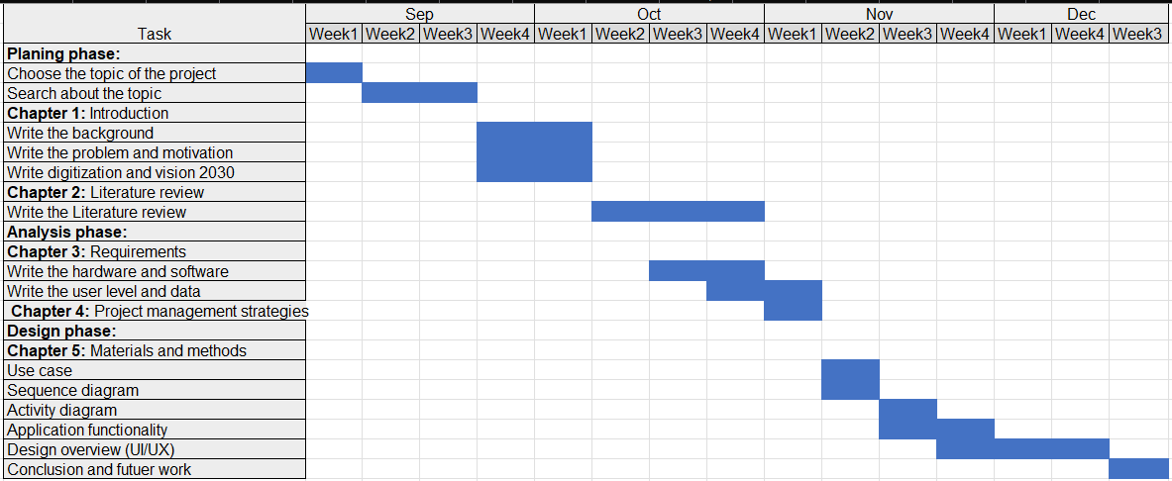

Table 5. Time line of the project (term2)

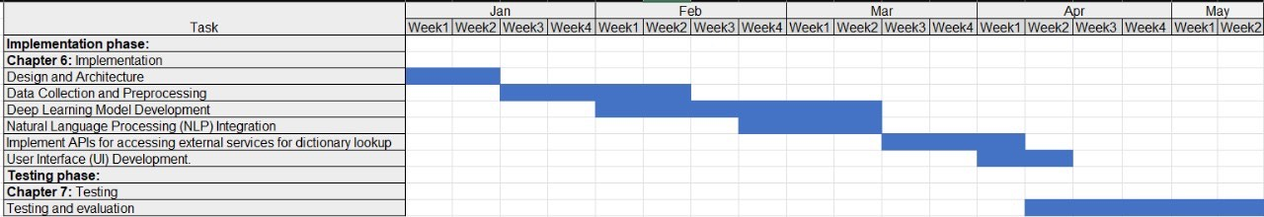

4.4 Suggested Business Modal

Mobile application usage has increased tremendously, and it’s a trend that’s only gaining steam. Nearly 90% of smartphone users spend time on applications, and 49% of people open an application more than 11 times a day. Consumers are increasingly making purchases on mobile devices, which can have a big impact on the customer journey — and on your business.

Our proposed business model centers around the development and deployment of an Arabic sign language Android application, aimed at addressing the needs of the Arabic sign language community. By creating this application, we can tap into a niche market and cater to the communication requirements of individuals who primarily use sign language. This endeavor presents several business benefits, including the opportunity to enhance inclusivity and accessibility by bridging the communication gap between sign language users and non-sign language speakers. Additionally, the application offers educational opportunities, empowering users to learn Arabic sign language through tutorials, lessons, and interactive features. By partnering with educational institutions, sign language schools, and deaf associations, we can foster collaborations and leverage their expertise and resources. Revenue generation can be achieved through various channels, such as offering paid premium features, in-application purchases, or partnering with relevant businesses for sponsorships. Moreover, this initiative contributes to brand building and reputation by showcasing our commitment to inclusivity and social responsibility. Successful implementation of the project can also lead to market expansion, allowing us to explore other sign languages and regions in the future. By combining technology and social impact, we strive to make a meaningful difference in the lives of the Arabic sign language community while building a sustainable and socially conscious business.

1. Materials and Methods

In this chapter, we will visualize our system design by modeling it into UML diagrams and the design overview (UI/UX), that explain what we are producing and how users will interact with it. The UML diagrams include the Use case, Activity diagram, and Application functionality. Each diagram will focus on a different aspect of the system. Windows 11 is the operating system that we are working on.

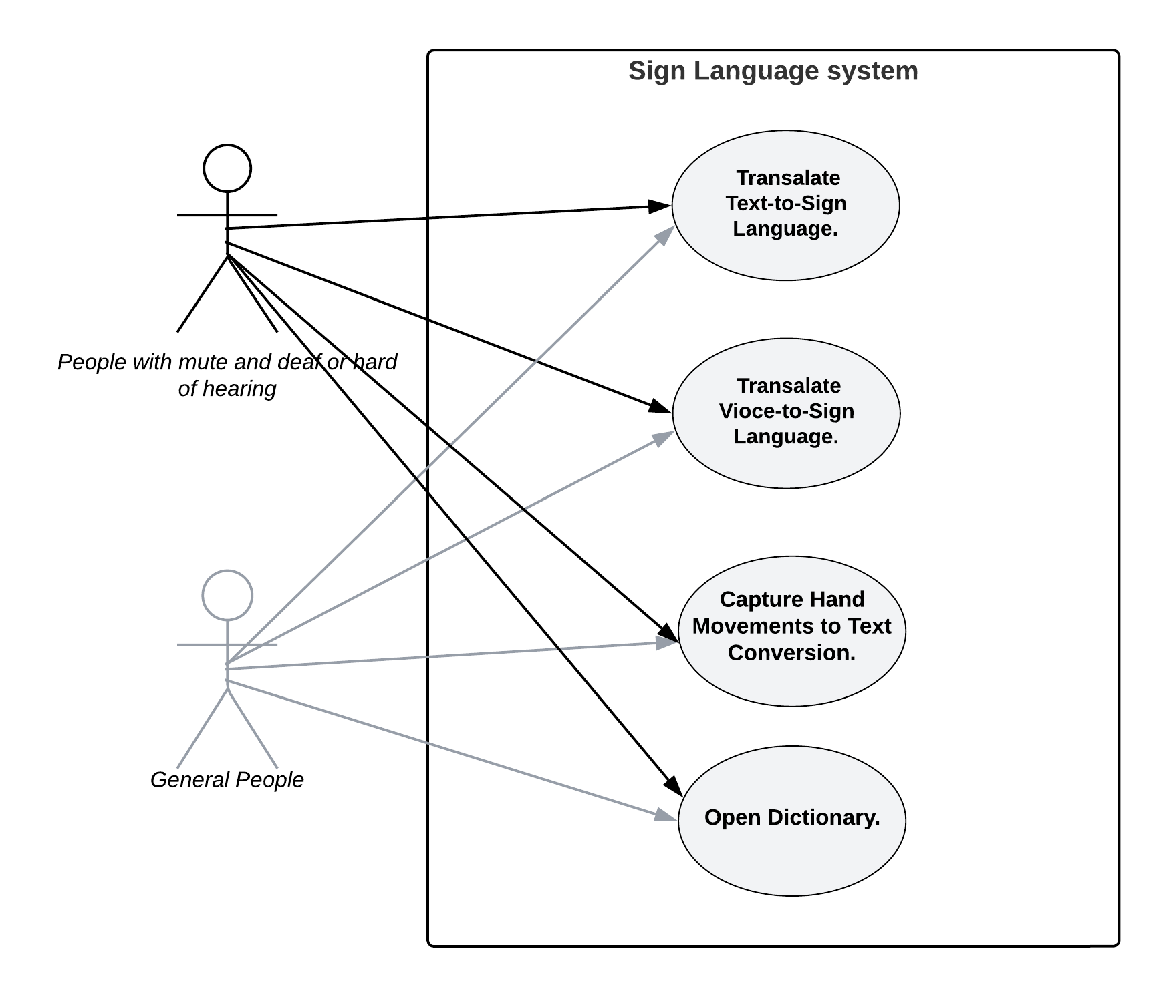5.1 Use Case

Figure 10: Use case diagram.

Table 6. Use case.

|  |  |
| --- | --- |
| Actors | Use Case |
| People with mute and deaf or hard of hearing. | Text-to-sign language conversion. |
| General people. | Voice-to-sign language conversion. |
|  | Visually captured hand movement to text conversion. |
|  | Dictionary. |

In figure 10, is focusing on how the system will achieve a specific goal for a specific user. Both people with mute and deaf or hard of hearing and general people have full control of the whole application features.

5.2 Sequence Diagram

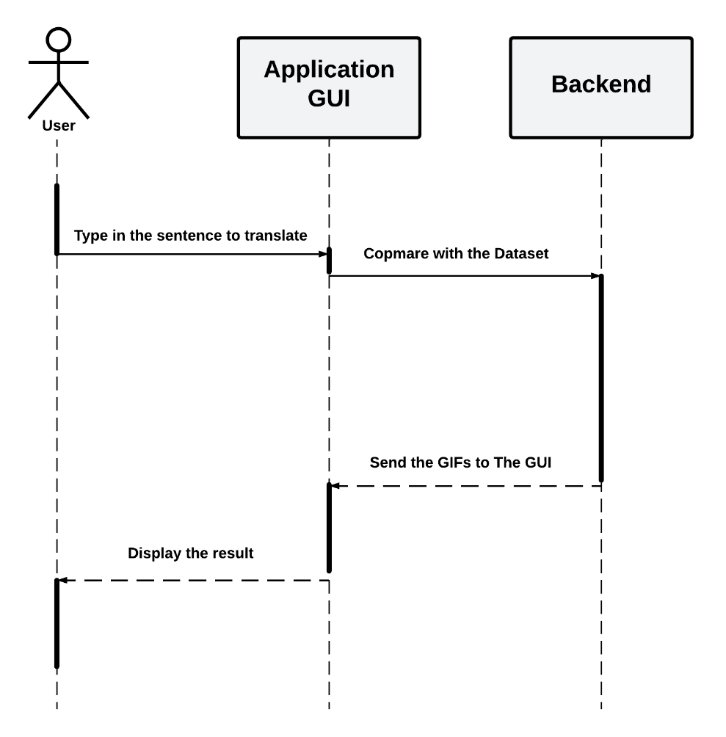

Figure 11: Sequence diagram illustrate the text-to-sign functionality.

The interactions between the user and the entire system while using the text-to-sign feature are depicted in the figure above. First user should write any sentence then with in the backend of the application the sentence will process and return a GIF sign language-based result.

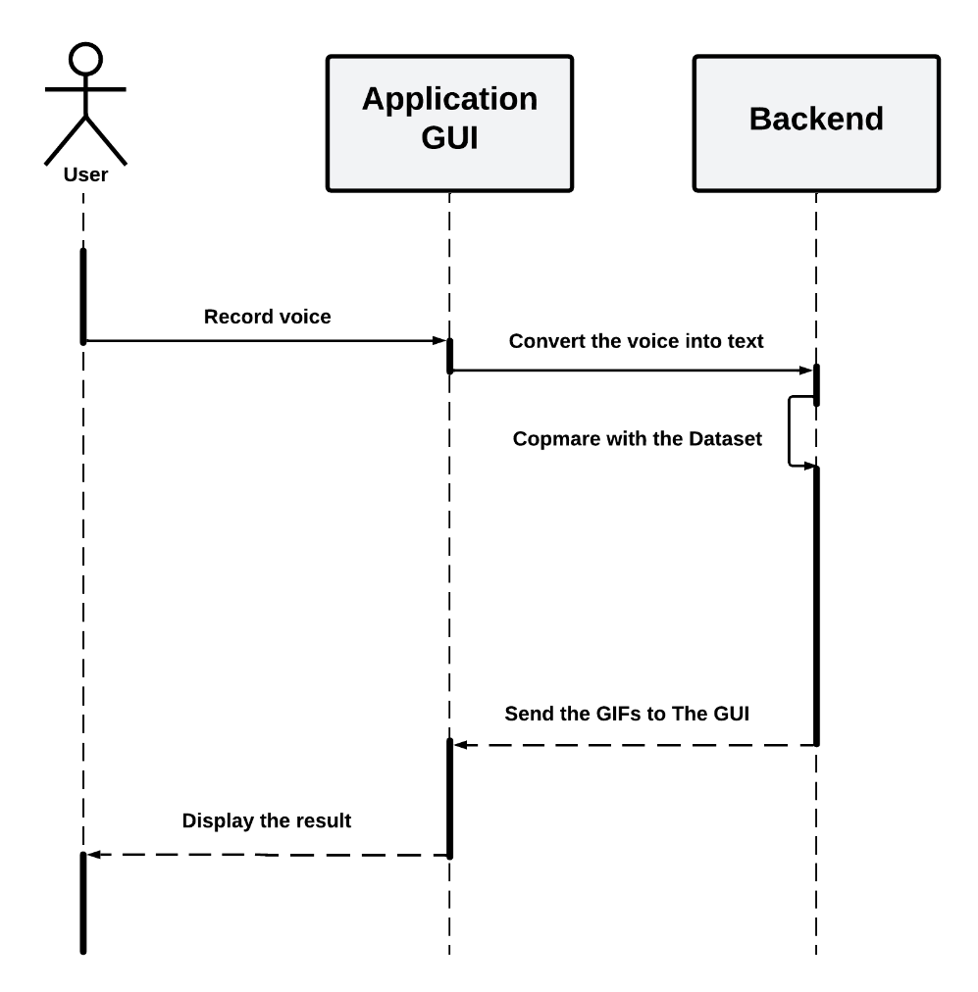

Figure 12: Sequence diagram illustrate the voice-to-sign functionality.

The interactions between the user and the entire system while using the voice-to-sign feature are depicted in the figure above. First user should say anything, then within the back-end of the application what he said will be processed and return a GIF or PNG sign language-based result.

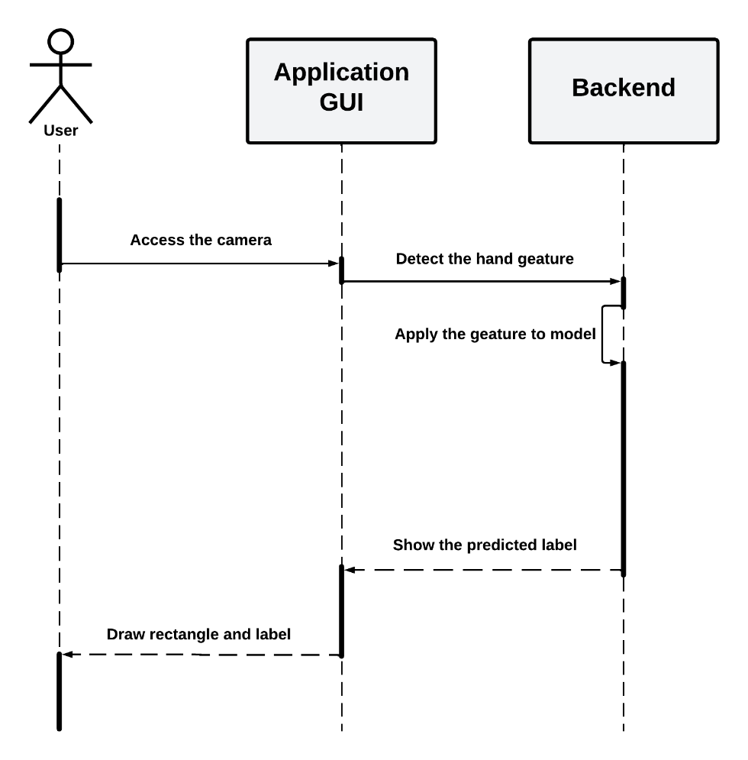

Figure 13: Sequence diagram illustrate real-time conversion functionality.

The interactions between the user and the entire system while using the real-time conversion feature are depicted in the figure above. Through the use of cameras, the system captures the sign gestures performed by the user. These gestures are then analyzed and recognized within back-end of the system. The system translates the recognized gestures into corresponding textual representations, and displaying it in the front-end to the user.

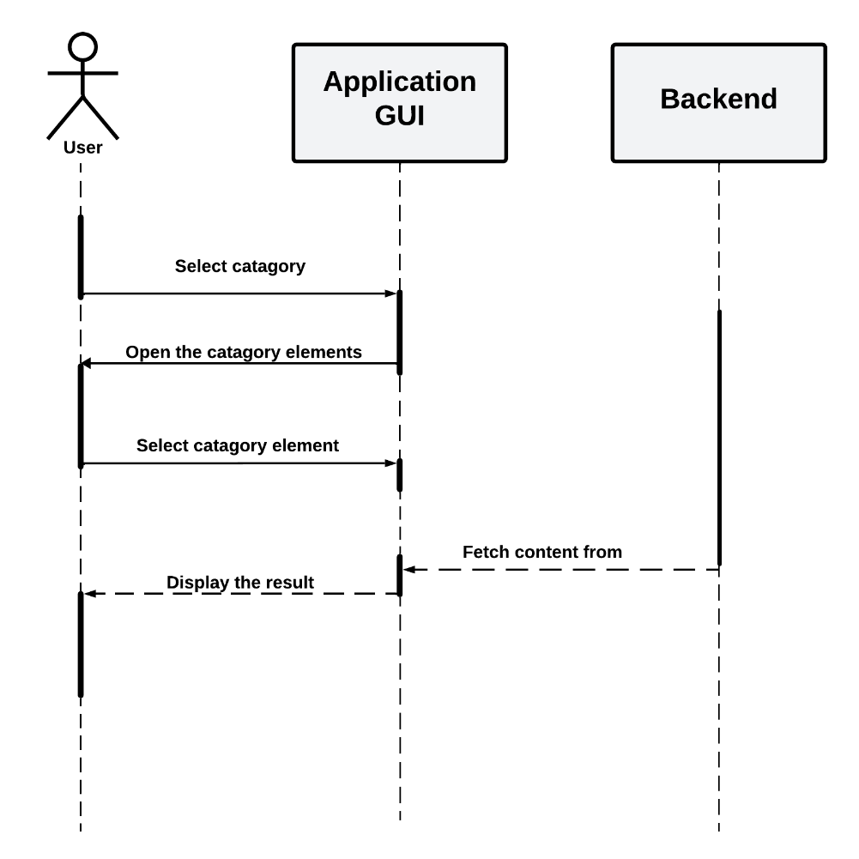

Figure 14: Sequence diagram illustrate the dictionary.

A dictionary with many categories offers text-to-sign gesture translation functionality provides a comprehensive resource for converting written text into corresponding sign language gestures. Users can choose a word from the dictionary, and the system will provide the corresponding sign gesture. The full interactions between the user and the system while using the dictionary are depicted in the figure above.

5.3 Activity Diagram

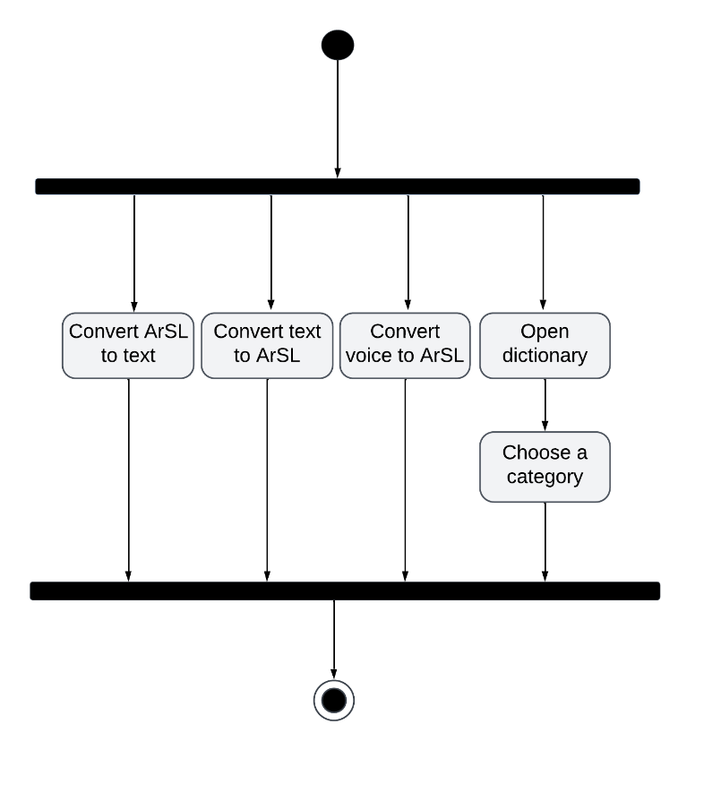

Figure 15: Activity diagram.

In Figure 15, the user can take any one of the following actions (Convert ArSL to text, convert text to ArSL, convert voice to ArSL, and open dictionary) in the open dictionary there is another required action to choose a category to browse the related words under it and learn from it.

5.4 Application Functionality

The functionality of an application is defined during the development process based on the project requirements and specifications. Developers and designers need to align the application's functionality with the intended purpose and user needs. Regular updates and enhancements to functionality may be made over time based on user feedback and evolving requirements. It is used to illustrate the barrel of communication between deaf-mute people and non-deaf-mute people that the application aims to solve.

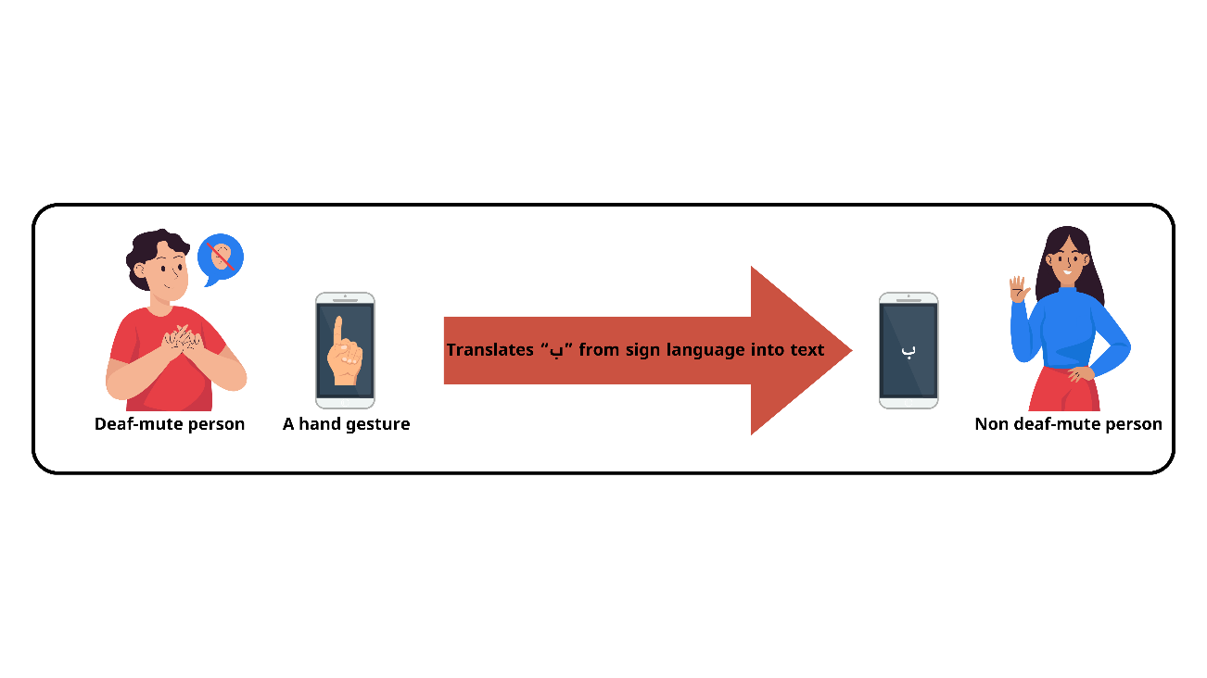

Figure 16: Real-time translation bridges communication between deaf/mute and non-deaf/mute via mobile camera.

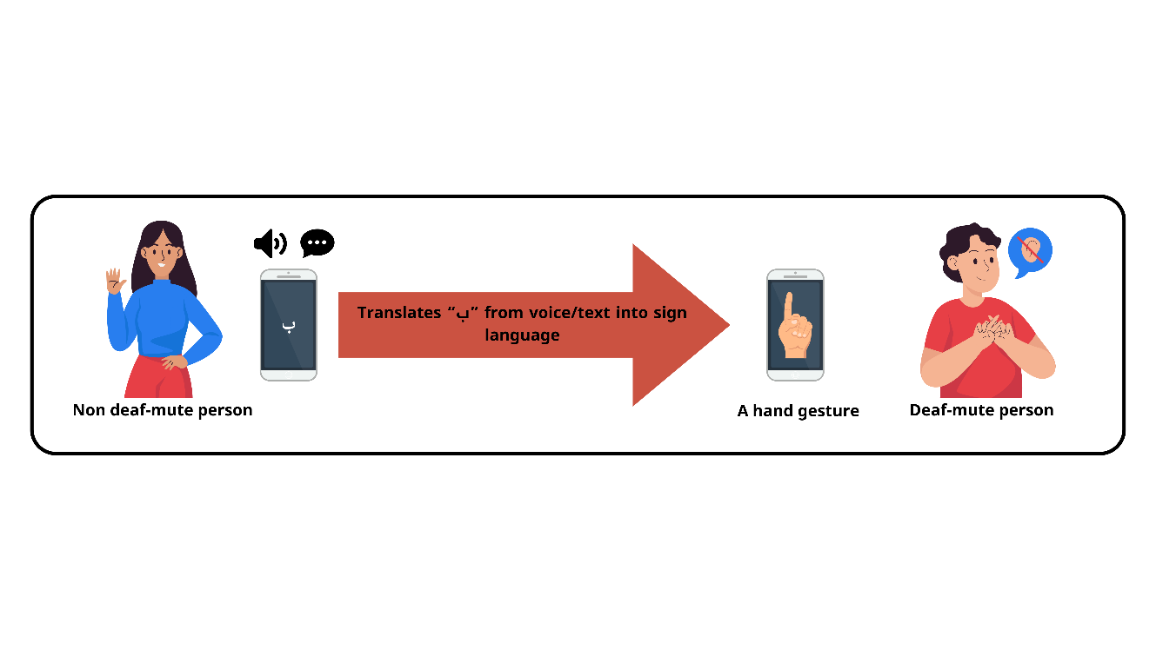

Figure 17: Communication without barriers: Voice and text interaction between hearing/speaking and deaf/mute individuals.

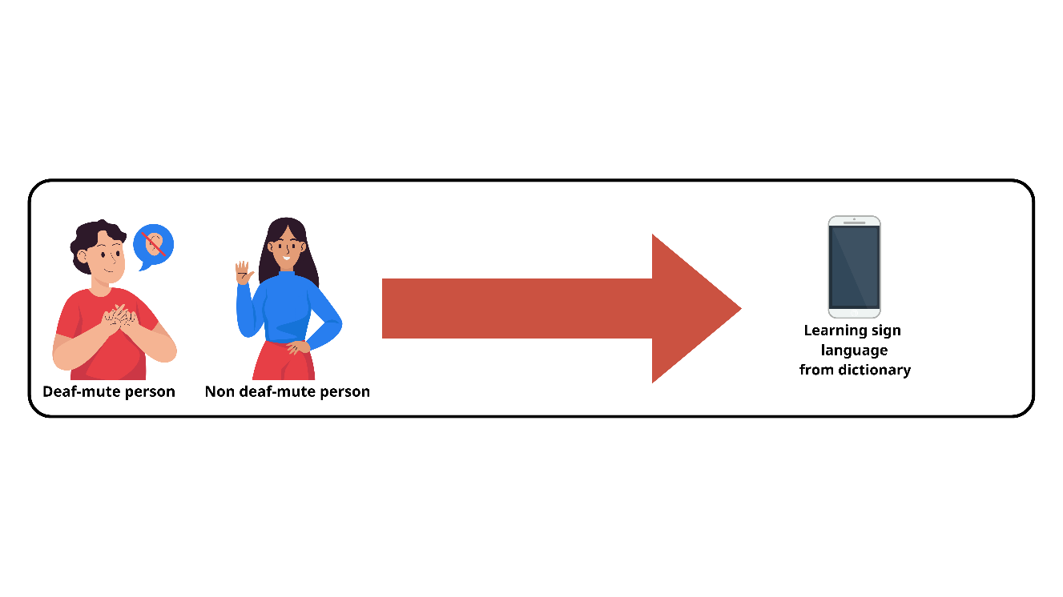

Figure 18: Inclusive learning: Arabic Sign Language for all.

5.5 Design Overview (UI\UX)

In our UI/UX design process, we have carefully crafted a user-friendly interface that prioritizes intuitive navigation and seamless user experience. The following images showcase key elements of our design:

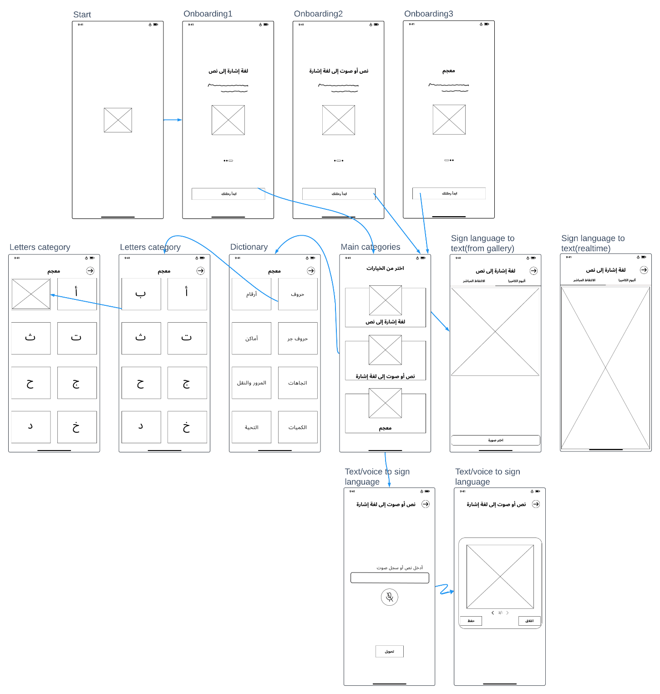

Figure 19: Simplified User Experience: Navigate, Discover, Engage.

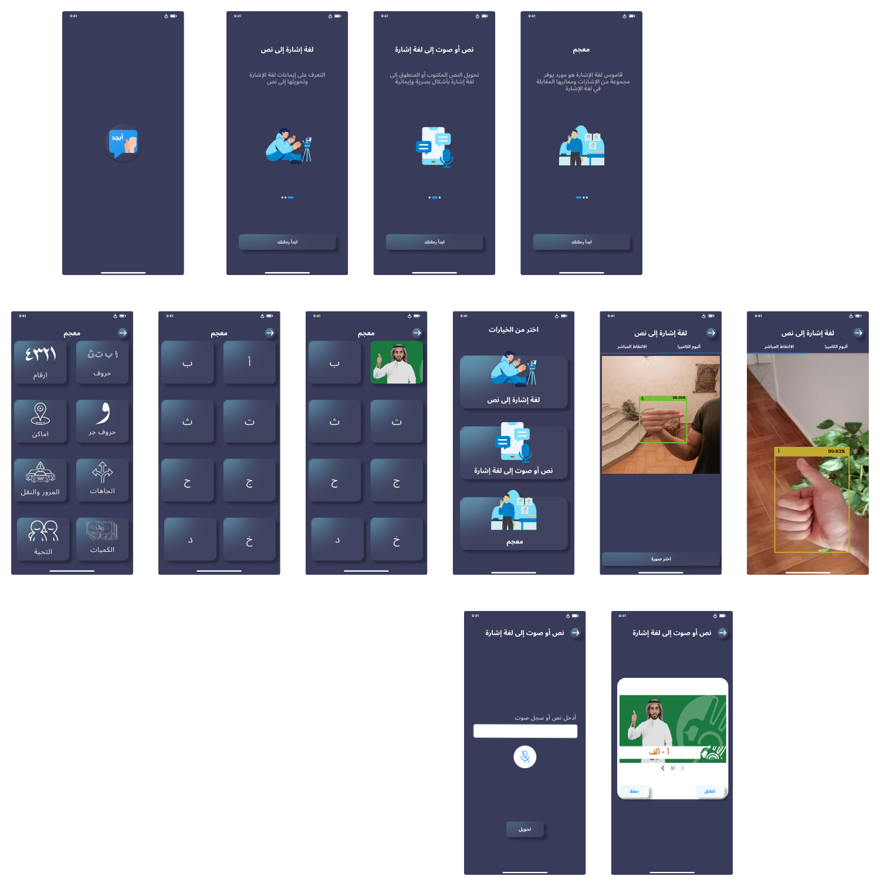

Figure 20: Stunning Modern User Interface: Enhancing User Interaction.

6. Results and Discussion

In this chapter, we present the outcomes of our meticulous testing and evaluation process, unveiling the performance and effectiveness of the Sign Language Translator Android application across its key features.

* **Real-Time Translation Category:**

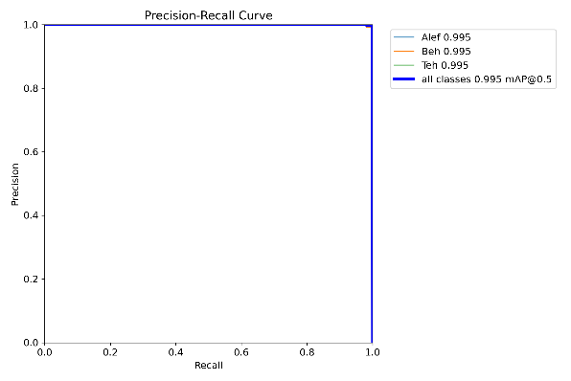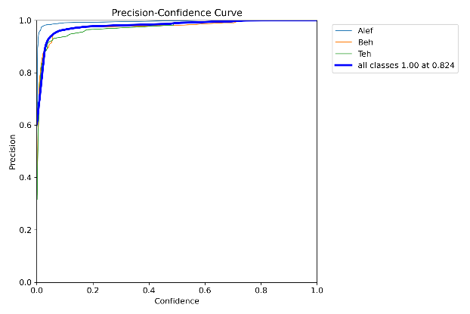

Figure 22: PR_curve.

Figure 21: P_curve.

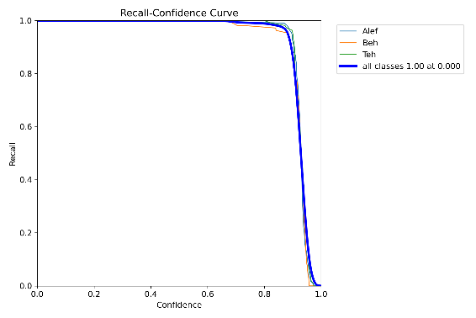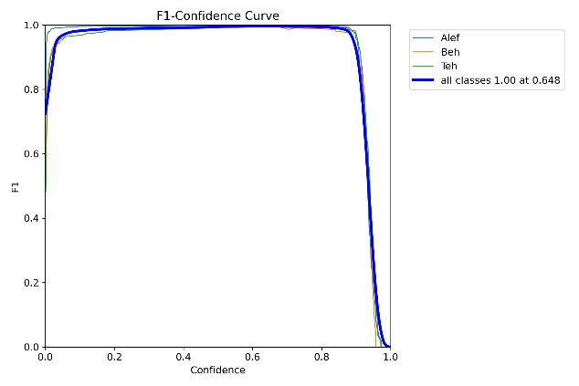

Figure 24: R_curve.

Figure 23: F1_curve.

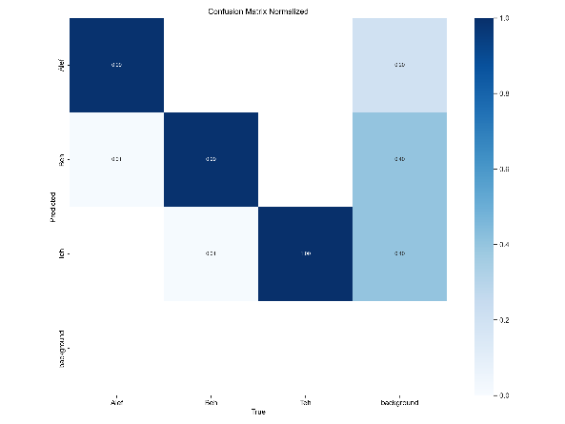

Figure 25: Confusion matrix.

Confidence, Precision, Recall, F1 Score, and Confusion matrix are evaluation metrics used to assess the performance of deep learning models. In Real Time Model, we have achieved high and accurate standards as shown in the graphs above. Precision and recall focus on the quality of positive and negative predictions, respectively. F1 Score provides a balance between precision and recall, making it a more comprehensive metric.

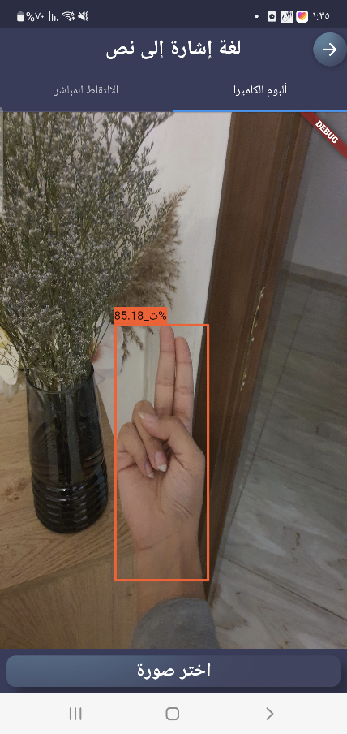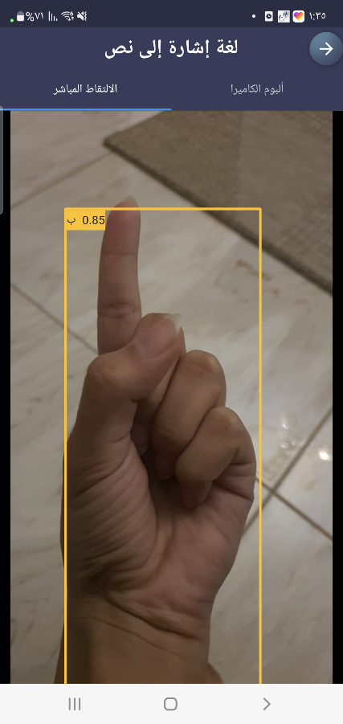

Figure 27: Interface of sign detection of image from gallery.

Figure 26: Interface of real time sign detection.

* **Translation Text/Voice into Arabic Sign Language (ArSL):**

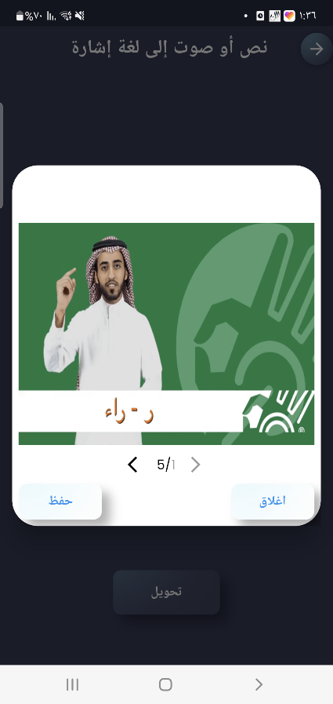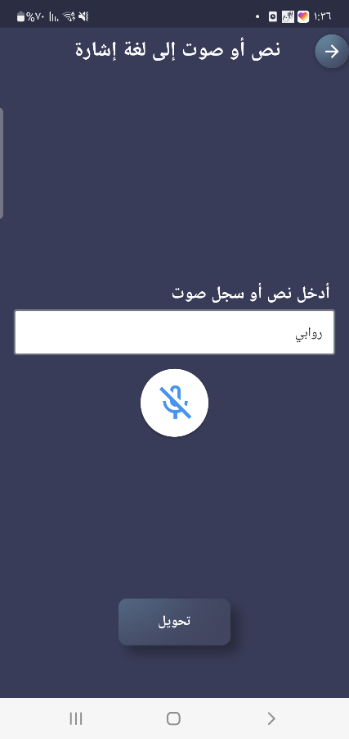

Figure 29: Interface of the result of translation.

Figure 28: Interface of text/voice into sign language translation.

* **Dictionary Category:**

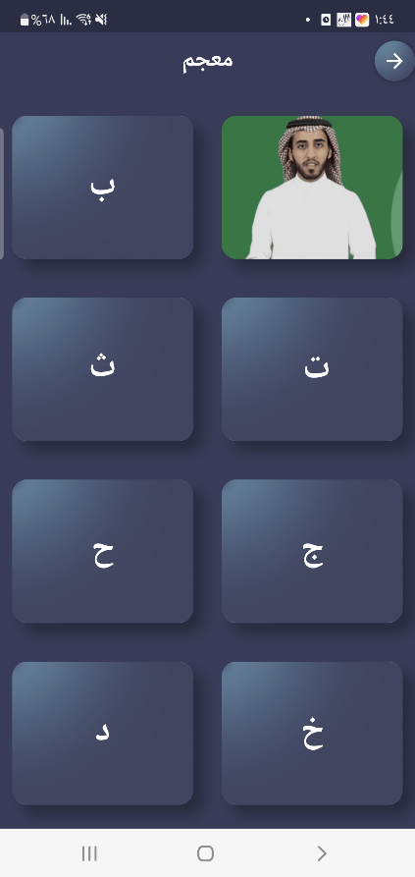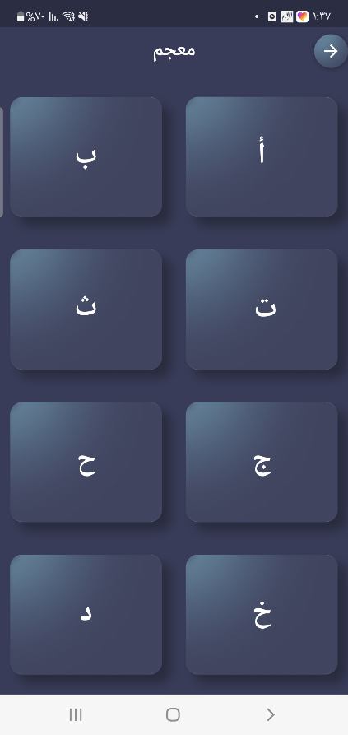

Figure 31: Interface of dictionary after flipping the card.

Figure 30: Interface of dictionary (alphabet section).

In the Discussion section, it's essential to acknowledge and address specific challenges encountered during the development process. Firstly, the absence of an annotated Arabic sign language data set posed a significant hurdle, necessitating our team to undertake the laborious task of creating one from scratch. This process involved meticulously collecting sign language gestures and their corresponding meanings to lay the foundation for training our machine learning models. Additionally, limitations in the CPUs, which only supported by flutter with PyTorch, resulted in lower performance, The main difference is that GPUs have smaller, simpler control units, ALUs, and caches—and a lot of them. So, while a CPU can handle any task, a GPU can complete certain specific tasks very quickly. Despite this setback, we optimized our algorithms to utilize GPU resources efficiently, albeit with slightly reduced performance. Moreover, the absence of a sign language expert within our team posed challenges in accurately interpreting and translating gestures.

7. Conclusion and Future Work

Sign languages are visual languages that utilize hand movements as a means of communication. They play a crucial role in facilitating communication for individuals with disabilities. Sign languages enable these individuals to express themselves, convey their emotions, and connect with others. However, a significant limitation arises from the fact that not everyone possesses knowledge of sign languages, which hampers effective communication.

To address this limitation, the development of automated Sign Language Recognition (SLR) systems becomes essential. These systems have the potential to accurately translate sign language gestures into commonly spoken languages, enabling seamless communication between sign language users and non-sign language users.

In this paper, the team of "Esharah Wahdah" aims to bridge the communication gaps and empower the deaf community. This initiative not only enriches the lives of individuals with hearing impairments but also contributes to fostering a more inclusive and understanding society. By leveraging advanced technology and machine learning algorithms, the team seeks to develop an SLR system that can recognize and interpret sign language gestures accurately, we strive towards a society that embraces diversity and empowers individuals with disabilities to actively engage in social interactions and achieve their full potential.

Our future work entails a twofold approach aimed at enhancing the capabilities and accessibility of our Sign Language Translator Android application. Firstly, we plan to transition to a GPU-based model for gesture recognition and translation, leveraging the parallel processing power of GPUs to significantly improve computational efficiency and real-time performance. This shift will enable us to achieve higher throughput and lower latency, thereby enhancing the application's responsiveness and user experience. Additionally, we intend to publish the application on Google Play stores to make it widely accessible to users worldwide. By making the application readily available for download and installation, we aim to reach a broader audience and provide valuable support for communication accessibility and inclusivity among sign language users and non-users. Through these future endeavors, we are committed to continuously advancing the capabilities of our Sign Language Translator application and fostering mutual understanding and communication between individuals, regardless of their linguistic backgrounds or abilities.

## **Biography**

* Students Profile



Rawabi Albaqami

Computer Science

[linkedin.com/in/rawabi-j-albaqami-5a6199283](https://www.linkedin.com/in/rawabi-j-albaqami-5a6199283)

Reem Alosimi

Computer Science

[linkedin.com/in/reem-alossimi-377a50198](https://www.linkedin.com/in/reem-alossimi-377a50198)

Lina Alfawzan

Computer Science

[www.linkedin.com/in/lina-alfawzan-5baa87282](http://www.linkedin.com/in/lina-alfawzan-5baa87282)

* Advisor Profile



Dr.samia dardouri

<https://www.linkedin.com/in/dardouri-samia-b4604024/>

Dr. Samia, is an Assistant Professor in the College of computing and information technology at Shaqra University, Saudi Arabia. Dr. Samia has got her Ph.D. in Computer Science at Carthage University in Tunisia. She received her master's degree in Computer Science at National Engineering School of Tunis, and Engineering degree in Computer Science at National Engineering School of Gabes in Tunisia. She has over 13 years of working experience in the academic sector.

# References

|  |  |
| --- | --- |
| [1] | V. J. a. K. S. M. Gärdenfors, "Spelling in deaf, hard of hearing and hearing children with sign language knowledge," Frontiers in Psychology, 10 November 2019. [Online]. Available: doi: 10.3389/fpsyg.2019.02463. |
| [2] | H. Lazizy, "موسوعة المبتكر," 26 7 2018. [Online]. Available: https://innoopedia.blogspot.com/2015/07/sign-language.html. [Accessed 28 October 2023]. |
| [3] | C. Ma, "A Wearable System for Sign Language Recognition Enabled by a Convolutional Neural Network," 1 11 2023. [Online]. Available: https://www.sciencedirect.com/science/article/pii/S2211285523006043. [Accessed 3 1 2024]. |
| [4] | Hee-Deok, "Sign Language Recognition with the Kinect Sensor Based on Conditional Random Fields," *Sensors,* vol. 15, no. 1, pp. 135-147, 2014. |
| [5] | R. Goutham, "Medium," The Startup, 24 March 2021. [Online]. Available: https://medium.com/swlh/a-beginners-guide-to-understanding-the-buzz-words-ai-ml-nlp-deep-learning-computer-vision-a877ee1c2cde. [Accessed 28 October 2023]. |
| [6] | "What is Natural Language Processing?," IBM, [Online]. Available: https://www.ibm.com/topics/natural-language-processing. |
| [7] | J. Elflein, "Statista," 26 April 2023. [Online]. Available: https://www.statista.com/statistics/888569/number-of-people-with-hearing-loss-worldwide-projections/. [Accessed 28 October 2023]. |
| [8] | Rosero-Montalvo, P.D., Godoy-Trujillo, P., Flores-Bosmediano, E., Carrascal-Garcia, J., Otero-Potosi, S., Benitez-Pereira, H., Peluffo-Ordonez and D.H., "Sign Language Recognition Based on Intelligent Glove Using Machine Learning Techniques.," 2018. [Online]. |
| [9] | Konstantinidis, D., Dimitropoulos, K., Daras and P., "Sign language recognition based on hand and body skeletal data.," in *3DTV-Conference*, 2018. |
| [10] | Zheng, L., Liang, B., Jiang and A., "Recent Advances of Deep Learning for Sign Language Recognition.," in *DICTA 2017 - 2017 Int. Conf. Digit. Image Comput. Tech. Appl.* , 2017. |
| [11] | Rautaray and S.S, "A Real Time Hand Tracking System for Interactive Applications.," in *Int. J. Comput. Appl. 18, 975–8887*, 2011. |
| [12] | Zhang, Z., Huang and F., "Hand tracking algorithm based on super-pixels feature.," in *Int. Conf. Inf. Sci. Cloud Comput. Companion, ISCC-C 2013. 629–634*, Proc, 2013. |
| [13] | Lim, K.M., Tan, A.W.C, Tan and S.C., " A feature covariance matrix with serial particle filter for isolated sign language recognition.," in *Expert Syst. Appl. 54, 208–218* , 2016. |
| [14] | Lim, K.M., Tan, A.W.C., Tan and S.C., "Block-based histogram of optical flow for isolated sign language recognition.," in *J. Vis. Commun. Image Represent. 40, 538–545*, 2016. |
| [15] | Gaus, Y.F.A., Wong and F., "Hidden Markov Model - Based gesture recognition with overlapping hand-head/hand-hand estimated using Kalman Filter.," in *Intell. Syst. Model. Simulation, ISMS 2012. 262–267*, Proc, 2012. |
| [16] | Nikam, A.S., Ambekar and A.G., "Sign language recognition using image based hand gesture," Conf. Green Eng. Technol. IC-GET, 2016. [Online]. |
| [17] | Mohandes, M., Aliyu, S., Deriche and M., "Arabic sign language recognition using the leap motion controller.," in *IEEE Int. Symp. Ind. Electron. 960–965* , 2014. |
| [18] | Enikeev, D.G., Mustafina and S.A., "Sign language recognition through Leap Motion controller and input prediction algorithm.," in *J. Phys. Conf. Ser. 1715, 012008*, 2021. |
| [19] | Suharjito, Anderson, R., Wiryana, F., Ariesta and M.C, *Sign Language Recognition Application Systems for Deaf-Mute People: A Review Based on InputProcess-Output.,* Procedia Comput. Sci. 116, 441–448, 2017. |
| [20] | Cheok, M.J., Omar, Z., Jaward and M.H, "A review of hand gesture and sign language recognition techniques.," *Int. J. Mach. Learn. Cybern. 2017 101. 10, 131–153,* 2017. |
| [21] | Wadhawan, A., Kumar and P., "Sign Language Recognition Systems: A Decade Systematic," *. Arch. Comput. Methods Eng.,* 2019. |
| [22] | Camgöz, N.C., Koller, O., Hadfield, S., Bowden and R., "Sign language transformers: Joint," *Proc. IEEE Comput. Soc. Conf.,* 2020. |
| [23] | Cui, R., Liu, H., Zhang and C., "A Deep Neural Framework for Continuous Sign Language," *IEEE Trans. Multimed. 21, 1880–1891,* 2019. |
| [24] | Bantupalli, K., Xie and Y., "American Sign Language Recognition using Deep Learning and," *Proc. - 2018 IEEE Int. Conf. Big Data, Big Data 2018. 4896–4899,* 2019. |
| [25] | Singha, J., Das and K., "Indian Sign Language Recognition Using Eigen Value Weighted," *(IJACSA) Int. J. Adv. Comput. Sci.,* 2013. |
| [26] | Kumar, P., Roy, P.P., Dogra and D.P., "Independent Bayesian classifier combination based sign," *Inf. Sci. (Ny). 428, 30–48,* 2018. |
| [27] | Sharma, A., Sharma, N., Saxena, Y., Singh, A. and Sad, "Benchmarking deep neural," *Neural Comput. Appl. 2020,* 2020. |
| [28] | Kishore, P.V.V., Prasad, M. V.D., Prasad, C.R. and Ra, "4-Camera model for sign," *Int. Conf. Signal,* 2015. |
| [29] | Tewari, D., Srivastava and S.K., "A Visual Recognition of Static Hand Gestures in Indian Sign," *Int. J. Eng. Adv. Technol.,* 2012. |
| [30] | Gao, W., Fang, G., Zhao, D., Chen and Y., "A Chinese sign language recognition system based," *Pattern Recognit. 37, 2389–2402,* 2004. |
| [31] | Quocthang, P., Dung, N.D., Thuy and N.T., "A comparison of SimpSVM and RVM for sign," *ACM Int. Conf. Proceeding Ser. 98–104,* 2017. |
| [32] | Pu, J., Zhou, W., Li and H., "Iterative alignment network for continuous sign language," *Proc. IEEE Comput. Soc. Conf. Comput. Vis. Pattern Recognit. 2019-June,,* 2019. |
| [33] | Kalsh, E.A., Garewal and N.S., "Sign Language Recognition System.".*Int. J. Comput. Eng. Res..* |
| [34] | Liang, Z., Liao, S., Hu and B., "3D Convolutional Neural Networks for Dynamic Sign," *J. 61, 1724–1736,* 2018. |
| [35] | Pigou, L., Van Herreweghe, M., Dambre and J., "Gesture and Sign Language Recognition with," *Proc. - 2017 IEEE Int. Conf. Comput. Vis. Work. ICCVW,* 2017. |
| [36] | Huang, J., Zhou, W., Zhang, Q., Li, H., Li. and W., "Video-based Sign Language Recognition". |
| [37] | Cui, R., Liu, H., Zhang and C., "Recurrent convolutional neural networks for continuous sign," *Proc. - 30th IEEE Conf. Comput. Vis. Pattern,* 2017. |
| [38] | Hore, S., Chatterjee, S., Santhi, V., Dey, N. and Ash, "Indian Sign Language Recognition Using Optimized Neural Networks.," *Adv. Intell. Syst. Comput. 455,,* 2017. |
| [39] | Dutta, K.K., Bellary and S.A.S., "Machine Learning Techniques for Indian Sign Language," *Int. Conf. Curr. Trends Comput. Electr. Electron. Commun. CTCEEC 2017.,* 2018. |
| [40] | "الترجمان في لغة الإشارة," Softonic, [Online]. Available: https://ltrgm-n-fy-lgh-l-sh-r.softonic-ar.com/android. [Accessed 23 December 2023]. |
| [41] | "بوابة وطن," تطبيق إشارة, [Online]. Available: https://www.watan.net.sa/452/%D8%AA%D8%B7%D8%A8%D9%8A%D9%82-%D8%A5%D8%B4%D8%A7%D8%B1%D8%A9. [Accessed 23 December 2023]. |
| [42] | "PyTorch," PyTorch, 2023. [Online]. Available: https://pytorch.org/. [Accessed 1 4 2024]. |
| [43] | "Firebase," Google, [Online]. Available: https://firebase.google.com/. |
| [44] | "Flutter - Build apps for any screen.," Google, [Online]. Available: https://flutter.dev/. |
| [45] | "Android Mobile App Developer Tools – Android Developers," Android Developers, [Online]. Available: https://developer.android.com/. |
| [46] | M. A.-B. a. A. A. a. M. A.-Y. a. M. A.-F. a. A. E. a. A. A. S. a. M. Al-Odat, "RGB Arabic Alphabets Sign Language Dataset," roboflow, 2023. [Online]. Available: https://universe.roboflow.com/rgb-arsl/rgb-arabic-alphabet-sign-language-aasl-dataset. [Accessed 1 April 2023]. |
| [47] | B. Bouallegue, "Arabic Sign Language Recognition System for Alphabets Using Machine," October 2021. [Online]. Available: https://www.researchgate.net/publication/355578534_Arabic_Sign_Language_Recognition_System_for_Alphabets_Using_Machine_Learning_Techniques. [Accessed 3 November 2023]. |
| [48] | M. Al-Barham, "RGB arabic alphabets sign language dataset," Kaggle, 11 July 2023. [Online]. Available: https://www.kaggle.com/datasets/muhammadalbrham/rgb-arabic-alphabets-sign-language-dataset. [Accessed 3 November 2023]. |
| [49] | "Tawasol - YouTube," Tawasol , 2015. [Online]. Available: https://www.youtube.com/@tawasol9282. [Accessed 1 April 2024]. |
| [50] | Wojciech-Marusarz, "nexocode," nexocode, 14 November 2022. [Online]. Available: https://nexocode.com/blog/posts/definitive-guide-to-nlp/. [Accessed 28 October 2023]. |
| [51] | S. Abbas, "PeerJ Computer Science," PeerJ Inc., 19 November 2021. [Online]. Available: https://peerj.com/articles/cs-741/#table-1. [Accessed 2 November 2023]. |
| [52] | "الترجمان في لغة الإشارة," Softonic, [Online]. Available: https://ltrgm-n-fy-lgh-l-sh-r.softonic-ar.com/android. [Accessed 23 December 2023]. |